Distribution list: Chiefexecutive@hart.gov.uk; committeeservices@hart.gov.uk
From: <Your Name>, <Your Address>, <Your Telephone Number>

Questions for Hart Council Regarding Local Plan

I would like to ask the following questions at the council meeting on 26 March 2015

Planned Housing Density on Brownfield and other sites
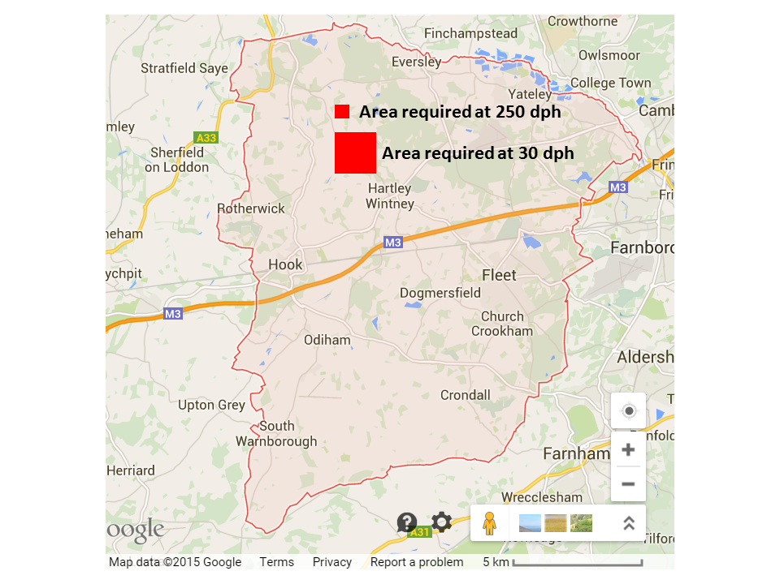

The analysis of the results of the FOI request about brownfield sites showed that the council doesn’t have a very robust approach to identifying and analysing brownfield sites in the district. However, further analysis also shows that the council adopts a rule of thumb for housing density of around 30 dwellings per hectare (dph). However, a study by a local architecture student has shown that in urban areas a planning density of around 250dph can create vibrant communities. This kind of metric could be applied to brownfield sites in both Hart and neighbouring districts such as Surrey Heath and Rushmoor. For instance, the Aldershot Barracks site could take all of Rushmoor’s entire requirement and maybe some of Hart’s too. Moreover, Hart District’s overall housing requirement of 7,534 dwellings would require ~251 hectares of land at 30dph, but only 30 hectares of land at 250dph. Building at a higher density would mean that a site such as Hartland Park could theoretically take Hart’s entire allocation.

Question: What is Hart District Council’s strategy for applying pressure to for instance Rushmoor to build at a higher density on the Aldershot Barracks site?
Question: What steps are Hart DC taking to investigate building at higher density on brownfield sites to protect our valuable green fields avoid urban sprawl?

Planning for the Ageing Population
Hart District Council it has a duty to meet the needs of many groups in society. Para 50 of the NPPF states:
“local planning authorities should…plan for a mix of housing based on current and future demographic trends, market trends and the needs of different groups in the community (such as, but not limited to, families with children, older people, people with disabilities, service families and people wishing to build their own homes)”
Over the course of the plan period up to 2032, there will be an extra 10,000 people over 60, including more than 6,850 over 75, expected to be living in the district and an extra 3,620 people who will be suffering from dementia or have some sort of mobility problem.
This will lead to a demand for additional specialist accommodation for older people. Let’s assume on average there’s 1.5 older people per dwelling because so many live on their own. That would be 6,850/1.5 = 4,566 units. Not all of them will want to leave their existing homes and some may go and live with family. So, let’s say we need half that number of new dwellings. That’s in round numbers 2,280 units. This assumes that all of the extra people with a mobility problem are also aged over 75.
Now let’s look at supply. Of the 7,500 houses we need to build up to 2032, around 3,500 have already been given planning permission, which leaves a balance of around 4,000. Of the 3,500 some are specialist units for the elderly – I know of a Churchill and McCarthy and Stone development in Fleet which will total around 100 units. This leaves around 2,180 units to find for the elderly.
If we were to build a new town and deliver around 2,000 units (this is much lower than the Barratts vision document) in the plan period, then this would leave around 2,000 units still left to grant planning permission for elsewhere.
As can be seen, if we build the new town, we will not meet the needs of the ageing population unless all of the remaining units are specialist units for the elderly and thus run the risk of the local plan being found unsound.
Question: What are the council’s plans to meet the needs of the ageing population in the local plan?

Infrastructure Costs

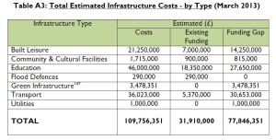
According to council documents, there is a current funding gap of around £78m for infrastructure in the district, not including the infrastructure requirements of a new town nor additional healthcare provision. Surrounding districts are also under pressure to build thousands of new houses in the plan period which will generate additional journeys within Hart because of identified work patterns.
Question: What additional CIL or S106 funding might the council expect to receive for building the additional 4,000 or so houses not already given planning permission?
Question: How will the amount of money vary according to the development strategy adopted (e.g. New Town versus Strategic Extensions versus Dispersal)?
Question: How will the infrastructure requirement and costs vary according to the development strategy adopted?
Question: What analysis is Hart carrying out to evaluate the impact on Hart’s infrastructure of rising population in neighbouring districts?
Question: How will Hart DC factor into its analysis the varying funding requirement and availability of alternative development strategies?

http://wehearthart.co.uk/2015/02/hart-district-council-has-no-brownfield-strategy/
http://wehearthart.co.uk/2015/03/rushmoor-could-take-all-of-harts-allocation-and-more/
http://wehearthart.co.uk/wp-content/uploads/2015/02/Hart-DC-Infrastructure-Delivery-Schedule-October-2014-Part-A-v2.pdf

