How well are we meeting the needs of Hart residents set out in the SHMA

Dear Councillor,

I am concerned about whether Hart Council’s planners have put in place the right measures and controls to ensure that we meet the needs of local people expressed in the SHMA.
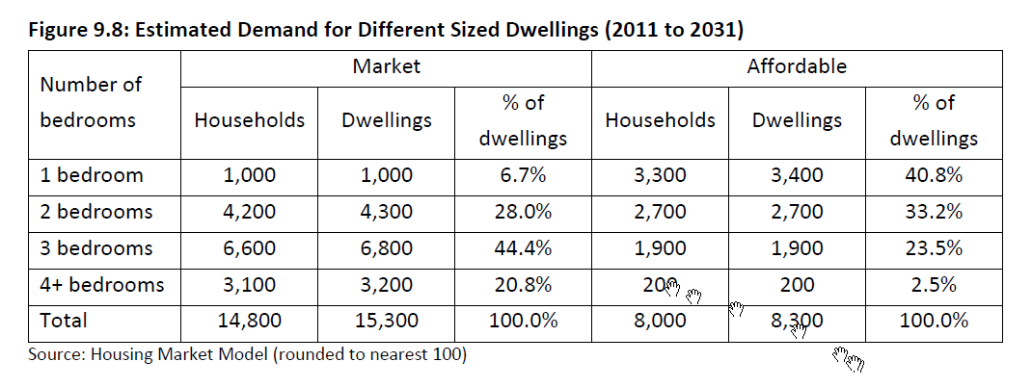
Figure 9.8 of the SHMA reproduced above, sets out the proportion of dwellings that we must build across market and affordable homes by number of bedrooms. Can you give a breakdown by number of bedrooms and by market and affordable, of the 4,500 or so dwellings built or permitted since 2011 and tell me how many more 1 & 2 bed homes need to be built out of the remaining ~3,000 to be permitted to meet the need expressed in the SHMA?
I note that para 9.28 of the SHMA says “The figures presented in Figure 9.8 can be used as a monitoring tool to ensure that future delivery is not unbalanced when compared with the likely requirements as driven by demographic change in the area”, so this is something the council should be monitoring on an ongoing basis and so shouldn’t be too onerous to produce.
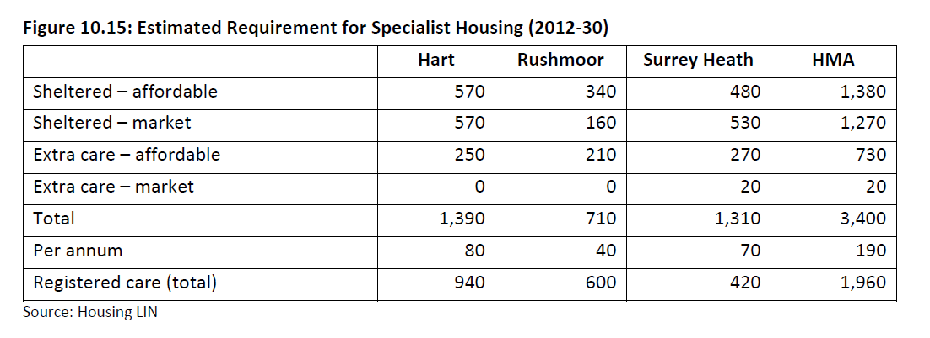
Figure 10.15 of the SHMA, reproduced above, calls for around 2,500 specialist units for the elderly, split into various categories to be built in Hart under the Local Plan, can you tell us how many of these units have been built or permitted since 2011, how many remain to be permitted?
I am sure you agree that it is important for the council to ensure that it is building the right types of houses in the right place to meet the needs of Hart residents.
Yours sincerely,

