

Hart District Council Local Plan Strategy and Sites 2016 - 2032
Publication Stage Representation Form

Part B: Please use a separate sheet for each representation.
For example, if you wish to comment on more than one policy, please submit a separate Part B form for each policy.
Please refer to the guidance notes before completing Part B.

Name/ Organisation:
Postcode:

- To which part of the Local Plan does this representation relate?

Paragraph Policy Policies Map

x

My representations relate to policies SD1, SS1, SS3, ED2, 4, 5 and 6, NBE2, I1, and Para 297 related to SANGs

- Do you consider the Local Plan is:

Please check as appropriate.
(1) Legally Compliant Yes ☐ No ☒
(2) Sound Yes ☐ No ☒
(3) Compliant with the Yes ☒ No ☐
Duty to Cooperate

- Please give details of why you consider the Local Plan is not legally compliant or is unsound or fails to comply with the duty to cooperate. Please be as precise as possible.
If you wish to support the legal compliance or soundness of the Local Plan or its compliance with the duty to cooperate, please use this box to set out your comments.

Continue on a separate sheet/scroll down box if necessary

- Please set out what modification (s) you consider necessary to make the Local Plan legally compliant or sound, having regard to the Matter you identified at question 3. above. (NB. Please note that any non-compliance with the duty to cooperate is incapable of modification at examination). You will need to say why this modification will make the Local Plan legally compliant or sound. It would be helpful if you are able to put forward your suggested revised wording of any policy or text. Please be as precise as possible.

Please note your representation should cover succinctly all the information, evidence and supporting information necessary to support or justify the representation and suggested modification, as there will not normally be a subsequent opportunity to make further representations based on the original representation at publication stage. After this stage, further submissions will be only at the request of the Inspector, based on the matters and issues he/ she identifies for examination.
- If your representation is seeking a modification, do you consider it necessary to participate at the oral part of the examination?

NO, I do not wish to participate at the oral examination ☒
YES, I wish to participate at the oral examination ☐

- If you wish to participate at the oral part of the examination, please outline why you consider this to be necessary:

Continue on a separate sheet/scroll down box if necessary
Please note the inspector will determine the most appropriate procedure to adopt to hear those who have indicated that they wish to participate at the oral part of the examination.
Appendix A

Introduction
My name is xxxx [explain why you are making a submission].
I strongly object to more unnecessary green field development.
My objective in this submission is to request for the Local Plan to be amended such that it is properly sound before submission, or failing that, for the Inspector to pass the plan with amendments. The main amendments I am seeking are:
- Removal of policy SS3 – New Settlement at Winchfield/Murrell Green
- Amendment of policy SS1 – Spatial Strategy
- Amendment of Policy ED4, ED5 and ED6 – related to Fleet town centre and other urban centres
- Amendment of NBE2 – Gaps between settlements
- Amendment of I1 – Infrastructure
- Amendment of policy ED2 and policies related to Para 297 – SANGS
I will make submissions on each of those points, however first it is important to deal with Legal Compliance issues.

Legal Compliance
This section splits into two parts. The first relates to the potential pre-determination of Winchfield/Murrell Green as a location for development and the second relates to the limited scope of the consultations that have been conducted compared to what local people should have been consulted about.
This analysis informs the reasoning behind challenging the policies above.

Pre-Determination of Winchfield/Murrell Green as a development location

November 2014

Since 2014 it has become apparent that several councillors have pre-determined that the Local Plan will include a new settlement and that will be in Winchfield. In summary, certain members of the council have frustrated all attempts to test other locations; they have even derailed versions of the Local Plan without a new settlement at Winchfield and ignored all opportunities to build an appropriate number of houses to meet our need. It is difficult to avoid the conclusion that certain members of the council had predetermined the outcome from the outset.

Inappropriate Scope of Consultation

In 2015, a number of concerned residents approached Peter Village QC and his colleague Andrew Tabachnik to seek an opinion on the lawfulness of the process that had been carried out to date.
Nearly three years after that advice, no consultation has been carried out on employment, retail, transport or infrastructure. The Council is therefore exposed on soundness. In particular, I believe that to press on with a new DPD about a new town would be inappropriate as there are undoubtedly better ways to address retail, transport and infrastructure issues facing the district without building a new town. Indeed many would argue that building a new town may well exacerbate many of the issues we currently face.
Remedy: We believe a suitable remedy to these issues would be to amend the Local Plan to remove policy SS3 and make an appropriate adjustment to Policy SS1 to reflect that removal.
Policy SS1:
New Settlement Area of Search
To help address longer term growth requirements7, an area of search is identified in this Plan for a new settlement (see the key diagram and Policies Map). The new settlement will be brought forward through a separate development plan document (DPD) in accordance with Policy SS3.
The entirety of Policy SS3 should be deleted.

Soundness
Now we turn to the subject of soundness.

Policy SS1 – Spatial Strategy
Policy SS1 deals with the spatial strategy. I disagree with the quantum of new housing proposed in the draft Local Plan.
First, the numbers proposed are far too high and they are unsustainable. Second, the long term effect of planning for too many houses is that the initial effects are compounded, leading to permanent unsustainability.

Proposed number are far too high and unsustainable
They propose 6,208 now homes over the plan period at a rate of 388dpa. This is both unnecessary and undesirable on a number of grounds.
The current draft Local Plan calls for 6,208 houses to be built over the period 2016-2032. Hart built 1,830 houses over the period 2011-2016. This makes the total target over the comparable period 8,038 houses. This is more than the prior target in the SHMA despite the new Government method for calculating housing need showing a much slower rate of building being required. The 2016 SHMA was unsustainable because it proposed a set of adjustments to the DCLG starting point that were spurious and unnecessary.
Building the extra houses would be unsustainable because even the SHMA itself admits, would result in additional people migrating into the district, who would then largely work outside, making additional road and rail journeys and adding to congestion. This is the very antithesis of sustainable development.
Moreover, the council has very spurious reasons for justifying its uplift on the DCLG figures:

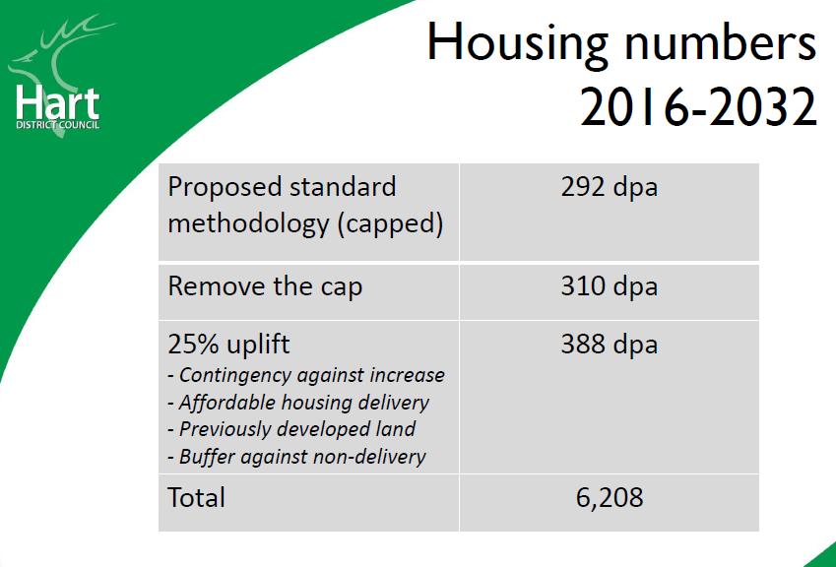
Their justifications for the 25% uplift are:
- Contingency against increase. I would suggest that adding to the housing target is an inappropriate way of dealing with this issue. It would be more appropriate demonstrate there is flexibility in housing supply to meet potential additional demand, rather than add extra demand without knowing it is there.
- Affordable housing delivery. This has already been accounted for in the 292dpa Government figure. In any event, as discussed above, building more won’t make a significant difference to house prices, and so won’t make houses any more affordable for people already living here, so it’s a spurious argument.
- Previously developed land. We have no idea what this means.
- Buffer against non-delivery. Again this is a spurious argument. The way to deal with this issue is to demonstrate flexibility in supply, not add additional demand.
Taken together, these arguments are weak and do not stand up to any sort of scrutiny.
Therefore we believe that the starting point for the Local Plan should be no more than the Government’s target of 292dpa or 4,672 dwellings in total. Because it isn’t yet clear whether Surrey Heath can meet its requirement, we would be prudent and add a few hundred to this to give a round number total target of 5,100 houses.
Remedy: We would therefore suggest that policy SS1 be adjusted accordingly:
New Homes
Subject to the availability of deliverable avoidance and mitigation measures in respect of the Thames Basin Heaths Special Protection Area, provision is made for the delivery of at least 6,208 5,100 new homes (388 319 new homes per annum) between 2016 and 2032.

Amendment of policy SS3 – New settlement
The most egregious part of the draft Local Plan is the proposal to include an unnecessary new town. This should be removed for the following reasons:
- The new town is not required, even with the inflated housing numbers in Policy SS1
- The proposal is unsustainable and undeliverable
- The supposed sweetener of a secondary school is unnecessary and won’t be placed in a viable location
- Will lead to coalescence with surrounding settlements
- Breaks a number of the council’s own objectives elsewhere in the plan
- It will hinder the much-needed regeneration of our urban centres, in particular Fleet

The new town is not required
As described above, the housing numbers in the draft Local Plan are too high. Even if one assumes the housing numbers are correct, the council itself admits that the new town is not required.
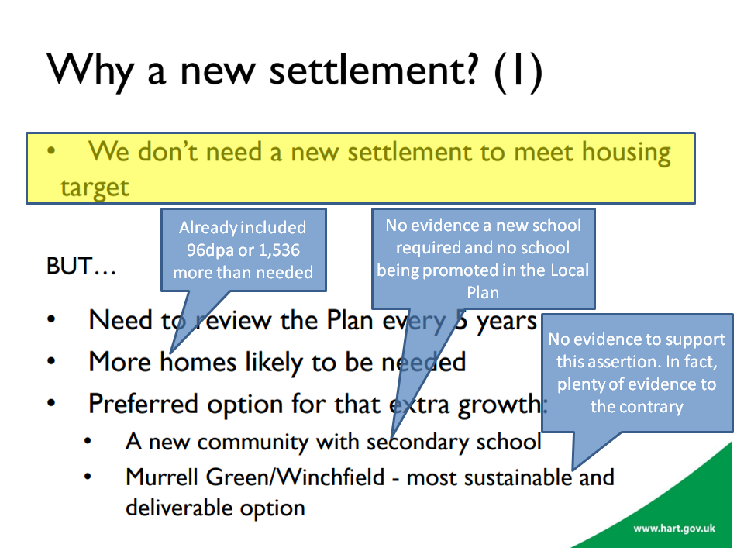
Not only that, the council themselves admit that the housing supply is under-estimated.
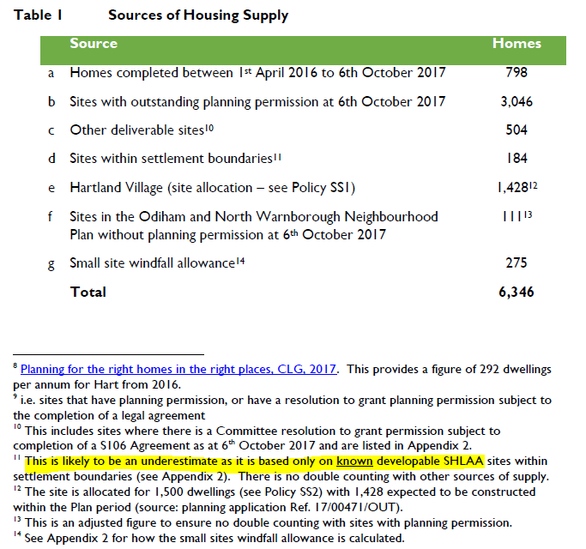
And even this under-estimate does not include housing supply identified in the Winchfield and Hartley Wintney Neighbourhood plans.
The combination of the over-inflated housing demand numbers and the under-stated housing supply numbers mean that the new town simply is not required.

The proposal is unsustainable
The area of search identified in the Local Plan contains a very wide area, consisting of the areas known as Murrell Green and Winchfield.
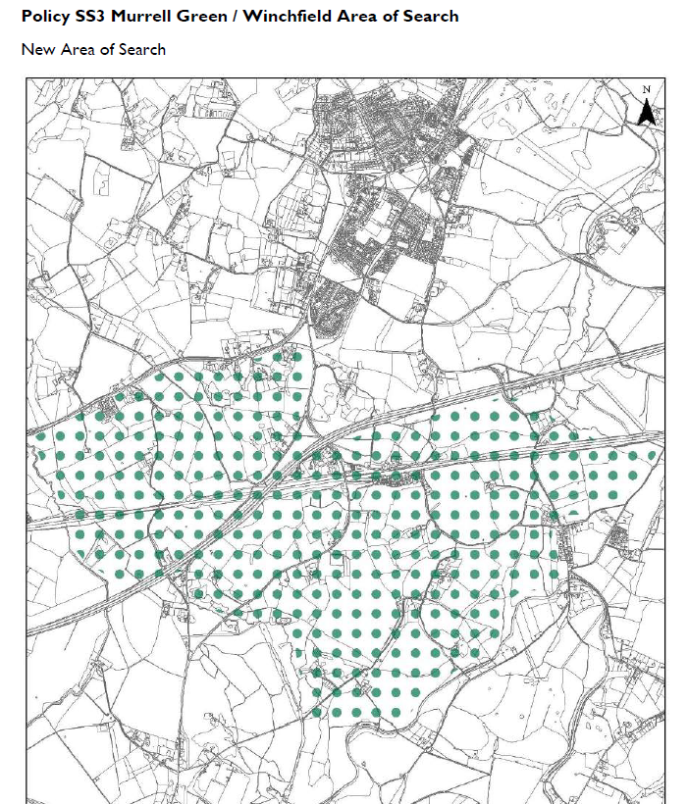

The attempts at sustainability appraisals of the Murrell Green and Winchfield sites have been poor, but nevertheless have demonstrated some very significant weaknesses that cannot be overcome.
Let’s deal with Murrell Green first. Part of the site, known as Beggars Corner was the subject of a planning application for a Solar Farm. This was refused on the grounds that it would spoil the views from Odiham. It is difficult to see how an 1,800 unit development would be any less intrusive than a solar farm. Moreover, that planning application identified that part of the Beggars Corner location is former landfill and some of it has unknown contents. This does not appear to be a suitable location on which to build new houses, or indeed form part of a SANG.
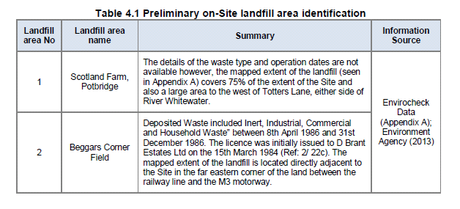
The sustainability appraisal conveniently did not cover this part of the proposed Murrell Green development.
Moreover, the SA did not manage to discover that there is a Major Accident Hazard Pipeline crossing the site. Not only that, the developer’s proposal included a secondary school sited right on top of the pipeline. After examination of the HSE rules regarding such installations, I conclude that neither houses nor schools will be able to be built within up to 100m of that pipeline. I also understand that roads should not cross such pipelines either. See analysis here.
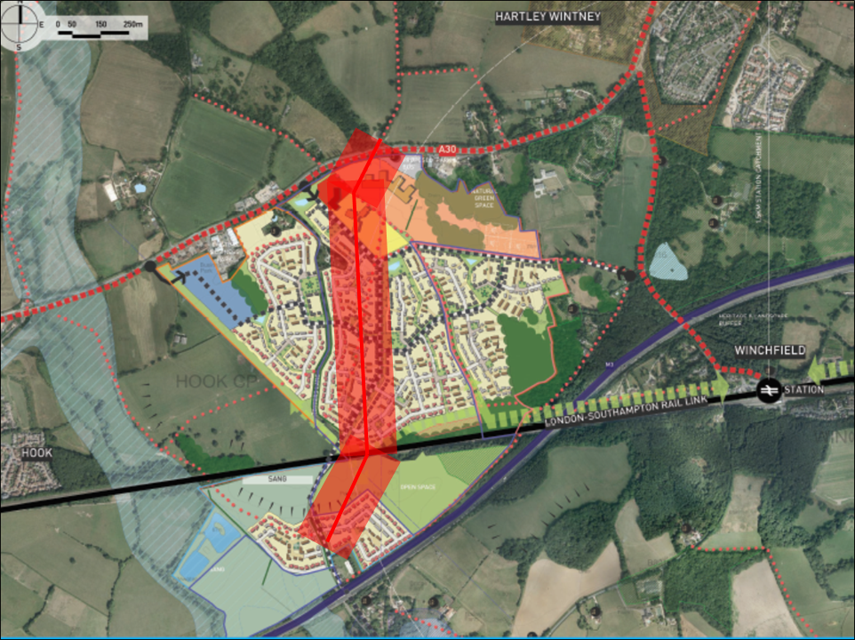
When one adds in other constraints such as SINCs, proximity of a high voltage power line, the railway and the M3, it appears the Murrell Green part of the area of search is not suitable for large scale development.
Turning to the Winchfield part of the area of search, it should be noted that the Winchfield sustainability assessment had to be extracted from HDC by FOI request. It can be found here.
The first point to note is that much of land in the Winchfield area of search is not in fact for sale. This comprises the central swathe known as Talbothay’s Farm plus other areas. Immediately, this leads to the conclusion that it won’t be possible to plan for a coherent settlement if the central part is not available.
In addition, the main areas considered to be constraints in the SA report were:
- Historic Environment
- Bio-diversity
- Landscape
- Water Quality
- Flood risk
More detail on this can be found here. Other spurious claims were made in the SA, such as the claim that building a “renewable and low-carbon energy generation and transfer” plant will diversify energy supply. What they mean is building a wood-burning power station utilising locally sourced timber (p74). Such a plant would be extremely undesirable since burning wood produces more CO2 than burning coal, and none of the proposed master plans include such space for such a plant. Plus, of course, I don’t think many people would support chopping down Bramshill forest to fuel such a plant. This claim was used to indicate that Winchfield was somehow more sustainable than other potential locations.
They also claim that building 3,000 new houses, with associated traffic will somehow “reduce the
emissions of greenhouse gases and manage the impacts of climate change”. Again, complete and utter nonsense.
They also say there was some evidence of wet ground at the far east of SHL183, but “no other obvious evidence of current or past flooding”.
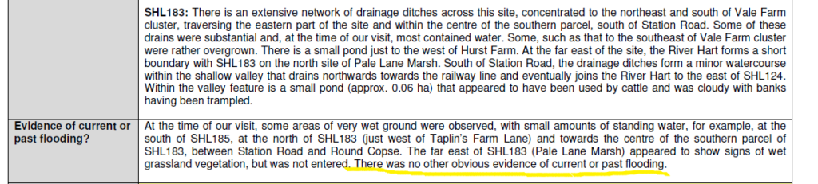
This is of course complete nonsense. The detailed assessment also says there’s only a one in 30 year chance of surface water flooding. The area of Taplins Farm Lane near the railway bridge flooded three times in 2016 alone. Evidence documenting the flood events can be found here (4 Jan) , here (7 Jan), here (9 March on Station Road) and here (28 March due to #StormKatie). I also understand that a similar area has flooded again in January 2018 and consistently floods after heavy rain. These are obviously more than one in 30 year events.
The area east of Winchfield fared less well than Murrell Green in the sustainability assessment even with the grossly understated the flood risk. And of course there were other issues with Historic Environment, Bio-diversity, Landscape and Water Quality. It is difficult to see how this could deliver a significant number of houses.
The area west of Winchfield was ruled out of the sustainability assessment, because it is a more peripheral location relative to the train station, does not offer a central focus and is in close proximity to Odiham SSSI. It therefore offers little prospect of significant housing development.
It is clear that there are very considerable constraints even before considering the infrastructure problems.
Hart has not put together proper estimates of the costs of infrastructure; despite saying it would do so.
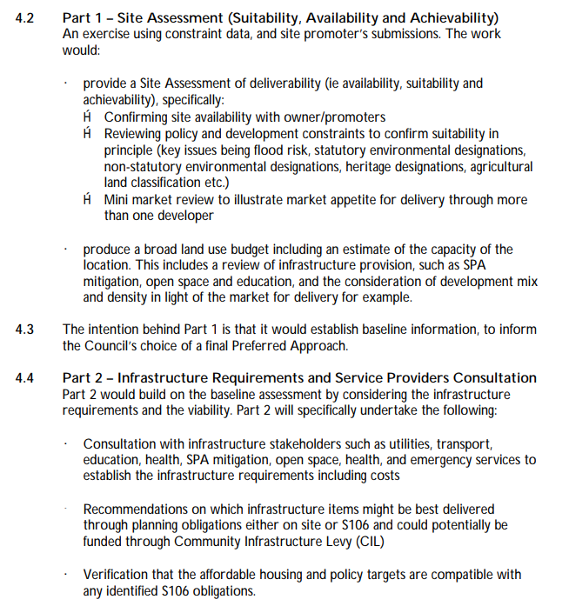
We Heart Hart have made several estimates that can be found here, here and here. Essentially, if a new motorway junction is required, the costs will be in excess of £300m. If the new junction is not required, the costs will be at least £200m. A rough schedule of requirements includes:
- Secondary school and three primary schools
- New sewage works
- Power station (as per SA)
- Improved drainage
- Re-routing or burying of electricity power lines
- Railway station upgrade to extend platforms and car park (or relocate)
- The bridges that carry the railway over Station Road, Taplins Farm Lane and Pale Lane will all need to be upgraded in some way
- New big roundabouts at either end of the B3016
- New smaller roundabouts from B3016 and A30 to the new town, new roundabout to join Pale Lane and the A323, new roundabout on A287/Crondall Road and at Pilcot Road/Hitches Lane
- New or widened roads at Bagwell Lane, Taplins Farm Lane/Church Lane, Station Road, Pale Lane and Chatter Alley/Pilcot Road. Plus many ancient hedgerows will have to be relocated.
- Potentially widening the A30 around Phoenix Green on the approach to Hartley Wintney
- New healthcare facilities
- New sports and community facilities
If this is a 5,000 dwelling new town, with 40% ‘affordable’, the remaining market houses might be expected to generate £15-20K per unit of S106/CIL. This would amount to around £45-60m. This is well short of the funding requirement and therefore might be expected to make the existing infrastructure funding gap worse.
Taken together, it is difficult to see how such a new town could be either sustainable or viable. Indeed, it is notable that in the three years of this saga, with many Hart Council members being supportive and apparently developers becoming anxious, no planning application has been made. Perhaps that’s because the developers also realise this is a pipedream.

Secondary school unnecessary and not in a suitable location
A number of councillors have made a fuss about a new settlement bringing a new secondary school. The trouble with this is that they have yet to provide a shred of evidence that a new secondary school is in fact required.
Back in 2015, Hampshire’s forecast went as far as 2018 and they were predicting a surplus of places up to 2018. They also forecast a falling birth rate and a significant number of existing pupils attending Hart schools from outside the district.
In 2017, HCC published a new school place plan that showed an overall surplus of places in both secondary and primary schools up to 2021.
A recent letter from a Hampshire Councillor shows that 98% of Hampshire secondary pupils have been allocated a place at a school of their choice for the next academic year.
So, having established that a new school is probably not required, we must now address the proposals that have been put forward over the past three years for the sites of new secondary schools.
First, we had Barratts in 2014 putting up a proposal to place a new school right next door to an institution housing sex offenders.
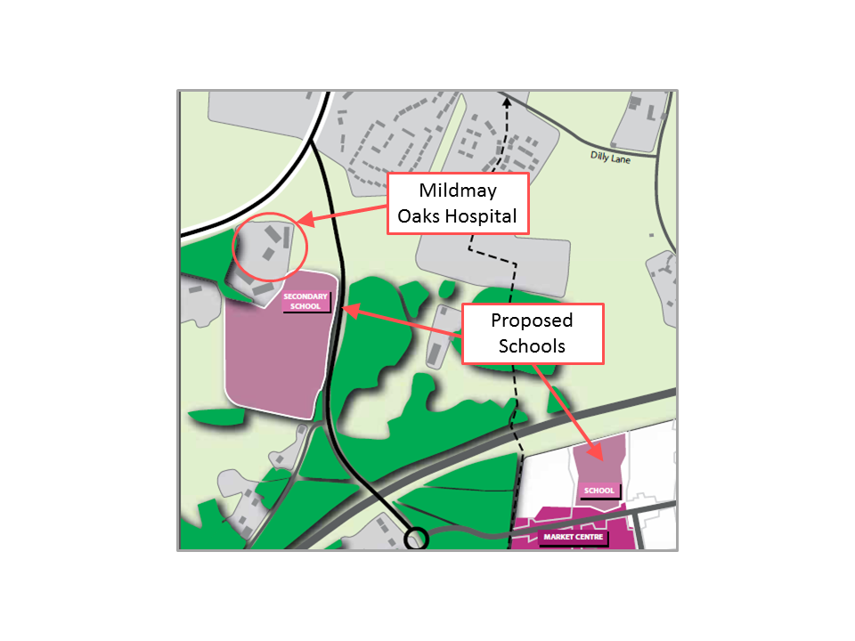
Then we had the proposal, described above to build a secondary school right on top of the high-pressure gas main running through the Murrell Green site.
More recently we have had another proposal from promoters of Winchfield which placed the secondary school directly under the high-voltage power lines.
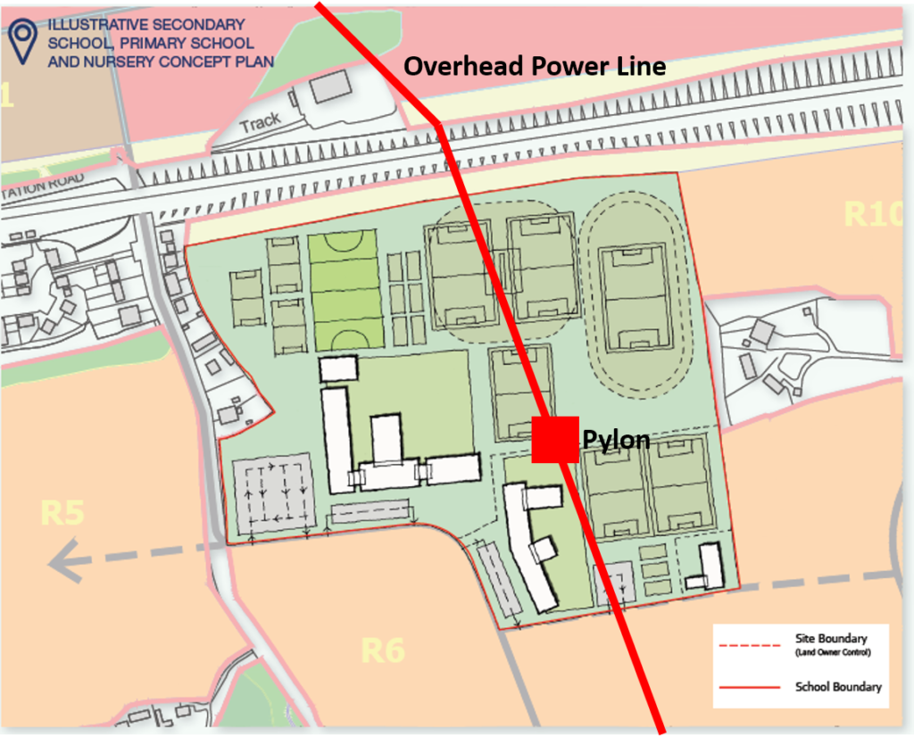
If after three years of trying, they cannot find a suitable location for a secondary school, one does have to come to the conclusion that they never will.
In summary, it is apparent that we don’t need a secondary school, and none of the developers involved have managed to find a suitable location.

Coalescence

The area of search is very wide. It borders Hook to the west, Hartley Wintney/Phoenix Green to the north east and comes very close to the Edenbrook development and the proposed Pale Lane development to the east. The bulk of the proposal also comes very close to Dogmersfield.
In other areas of the Local Plan, the council have been quite assiduous in defining strategic gaps. They have produced no such gaps around the new area of search, nor to the east of Hook or anywhere around Hartley Wintney. Nor are any gaps proposed to the north west of Fleet.
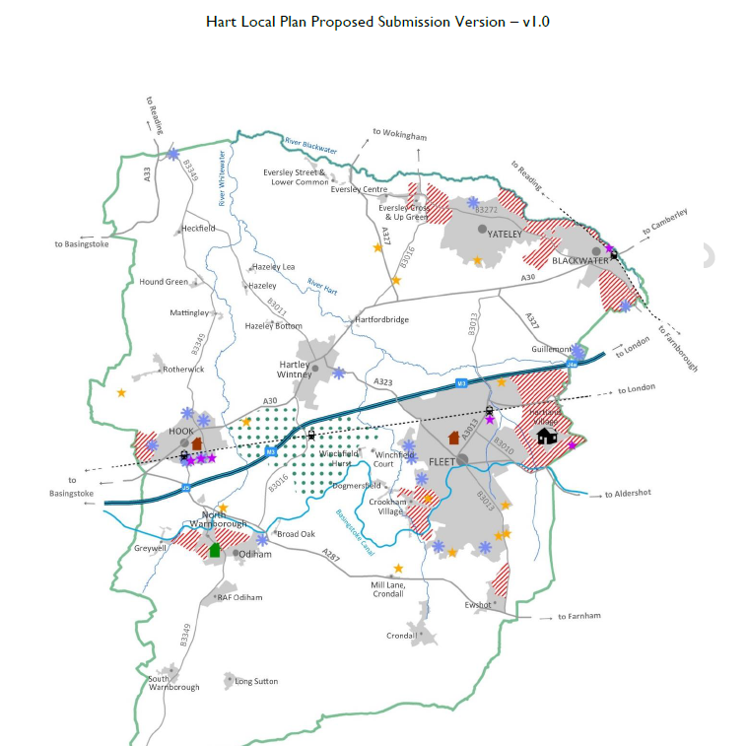
If they are allowed to go ahead with this area of search, unconstrained by strategic gaps, there is a strong risk that they will come up with proposals that lead to coalescence of our proud villages.

Breaks Objectives
Elsewhere in the Local Plan, Hart have come up with a number of objectives. These are reproduced below with my comments in bold on how these proposals break those objectives.
5. To support the vitality and viability of the District’s town and village centres to serve the needs of residents. Adding a new settlement will draw retail traffic away from our existing urban centres, most notably Fleet, and lead to even faster degeneration of Fleet as a retail destination. This can hardly be described as supporting vitality and viability.
9. To conserve and enhance the distinctive built and historic environment in the District including the protection of heritage assets and their settings. The proposed area of search includes a Norman church dating back to the Domesday Book and several SSSI’s including at Odiham and Basingstoke Canal. There are numerous other distinctive and historic buildings. Building a new settlement right next door to these valuable assets with neither conserve nor enhance the environment.
11. To protect and enhance the District’s natural environment, landscape character, water environment and biodiversity, including ensuring appropriate mitigation is in place for new development to avoid adverse impacts on the Thames Basin Heaths Special Protection Area (TBHSPA).Building a new settlement in one of the most attractive parts of the district, containing many woodlands and hedgerows supporting much wildlife such as deer and kingfishers, used by many for leisure and recreation will actively damage the landscape and biodiversity.
12. To provide measures for adapting to the impacts of climate change and minimising the contribution of new development to the causes of climate change, including reducing the risk of flooding by directing development away from areas at risk of flooding, and using opportunities offered by new development to reduce the causes and impacts of flooding from all sources. We have already established that the SA grossly under-stated the flood risk in the area known as Winchfield East, yet they are proposing to build on this area, directly against their stated objective.
13. To promote healthy and sustainable local communities through protecting and enhancing community, sport, health, cultural, recreation and leisure facilities, and through the delivery of a multi-functional green infrastructure network across the District. We already have a multi-functional green infrastructure network in Winchfield used for recreation and leisure. Building on it will destroy it, again directly contravening their own objective.
14. To maintain the separate character and identity of settlements by avoiding development that would result in their physical or visual coalescence. Again, we established the risk of coalescence earlier. This proposal, if implemented would effectively create a single urban conurbation from Hartland Park in the east, across Fleet and Hartley Wintney to Hook in the west. This is an appalling prospect, again directly breaking their own objective.
Remedy: I would propose that Policy SS3 is removed entirely, and consequent amendments are made to SS1 as described above.

Amendment of Policies ED4, ED5 and ED6 – related to Fleet town centre and other urban centres
Fleet is the lowest density town of its size in the country. The chart below shows that there is significant scope for increasing development density in Fleet.
The BBC has recently interviewed a number of people in Fleet about what it is like to live there. Everybody loves it, but they think there's been too much housing and not enough infrastructure. The draft Local Plan won't fix either of those issues, because they’re insisting on building too many houses and aren't addressing infrastructure.
Policies ED4, 5 and 6 effectively cast the existing centres in aspic and preclude significant redevelopment. I do not have the resources available to me to completely re-write these policies.
Remedy: Policies ED4, 5 and 6 should be removed for the time being and a proper community team put together to work with our local councillors and MP to come up with a master plan to regenerate our town centres.

Amendment of NBE2 – Gaps between settlements
As already identified above, the Local Plan identifies strategic gaps between settlements.
However, no gaps are proposed to the east of Hook, to the north west of Fleet or anywhere around Hartley Wintney.
This policy needs to be amended to include (the first two restore the position of strategic gaps in the prior Regulation 18 consultation, that we don’t recall many, if any people objected to, so it is difficult to see what evidence was used to remove them):
- A gap to the west of Hook from the east bank of the River Whitewater to at least the power line between Hook and Hartley Wintney
- A gap to the south and west of Hartley Wintney/Phoenix Green. This should be at both sides of the A30, from the existing end of development to the Murrell Green light-industrial estate and from St Mary’s Park to the motorway
- A gap from Elvetham Heath/A323 to the River Hart and from Edenbrook/Hitches Lane to the River Hart
- A gap from the east of Taplins Farm Lane/The Hurst to the River Hart

Amendment of I1 – Infrastructure
One leading councillor has gone on the record, calling for an ‘infrastructure led’ Local Plan. Yet, they have not allowed questions to be put to them about infrastructure, let alone answer them.
Back in October 2014, Hart Council produced an infrastructure delivery schedule that set out the current deficit, split by type and area. This shows a deficit of £78m not including healthcare facilities.
The breakdown of the costs by area showed the Fleet/Church Crookham and Hook areas had by far the largest deficits.
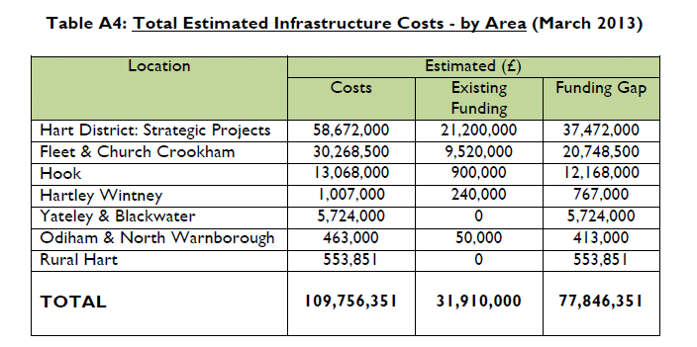
It should be noted also that SWR has recently put forward proposals to reduce services at Winchfield and Hook, exacerbating the rail capacity problem. The Local Plan doesn’t even mention improvements to the rail network in infrastructure policies.
A more recent estimate from Hampshire County Council has estimated the infrastructure funding gap for Hart as £72m.
Hart’s share of the gap is made up of:
- Transport, £34m
- Education: £38m.
- Countryside: To be Determined.
- Extra Care places: To be Determined.
No estimate has been made of the requirements or costs of additional healthcare provision.
The infrastructure policies in the Local Plan are feeble and fail to address the funding gap.
Yet, the National Planning Policy Framework (NPPF) is clear that infrastructure must be planned alongside new housing. Failure to adequately plan for infrastructure requirements and costs could lead to the Local Plan being found unsound. See references to paras 17 and 177 of the NPPF.
It is clear from the above, that the proposals to build a new town will probably exacerbate the existing funding gap and not deliver any infrastructure in Fleet and Church Crookham, the very places where funding is most required.
Remedy: I therefore think the remedy to this issue should be that policy SS3 is removed in its entirety (with consequent changes to policy SS1 already outlined elsewhere). The infrastructure policies should be reworked to address the real issues facing the district.
We believe that in preparation for the next review of the plan, a new policy should be created to regenerate our urban centres including attracting private capital so that we create a better place to live and address the existing infrastructure problems before even considering a new town that will only make matters worse.

Amendment to Policy ED2 and policies related to Para 297 – SANGS

Policy ED2 relates to safeguarding employment land and Para 297 refers to SANG owned by the council.
Policy ED2 protects essentially every major employment site in the district from redevelopment, despite many of the sites being of poor quality and uneconomic to refurbish.
The consequences of this policy will be to discourage redevelopment of sites and either lead to more sites being simply converted or worse, sitting idle as eyesores.
We believe this is contrary to Government policy.
Remedy: Consequently policy ED2 should be removed.
Moreover, the Inspector should be aware that the council has implemented a new policy regarding SANG that effectively further obstructs brownfield development. This is already blocking schemes that would provide homes that ordinary people can afford (as distinct from Affordable Homes that ordinary people can’t afford). The schemes affected are a conversion on Ancells Farm and proposals to redevelop the old police station in Fleet town centre. It has been suggested that this SANG policy may be unlawful.
In addition, Hart has commenced work to implement an Article 4 direction to block development on brownfield sites.
In effect they have set some nice sounding objectives about protecting our historic assets and building green infrastructure, but their policies act against their objectives and actively create a worse place to live by leaving decrepit buildings to rot and scar the landscape.
We think the Inspector should also take a view on these policies since they are closely related to the Local Plan, even though they are not contained within it.
Remedy: We believe that the SANG policy and the Article 4 direction should be removed.

