Email to: timetable.feedback@swrailway.com
Dear Sir,
Thank you for listening to feedback on how damaging your original timetable changes would have been to Hook and Winchfield stations. I understand you have now put forward alternative proposals and opened them up to consultation too. My first point is that changing the consultation question and proposals part way through is confusing. It is difficult to see how you can derive a valid result from such a process.
I also note that materials indicating that this consultation exists, let alone the impact it will have are notable by their absence from Winchfield station. I would like to request that you arrange a public meeting on the consultation locally, for residents in Hart, specifically Hook, Fleet and Winchfield station users.
However, I have summarised my understanding and impact of the new proposals below. I have created a chart to compare the current, 1st proposals and 2nd proposals below:
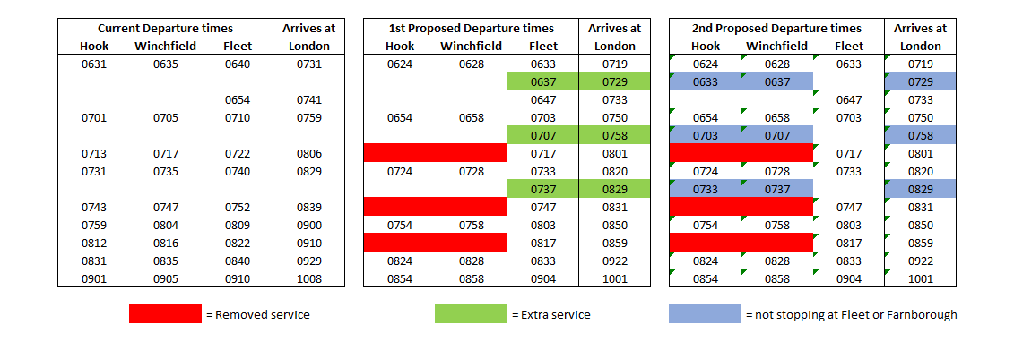
In summary the changes proposed are:
- Retains the same number of services from Hook and Winchfield to London, however, many of these services now no longer stop at Fleet and Farnborough
- Reduces the number of services that stop at Clapham Junction
- Keeps the same number of Fleet to London services as now
- The new proposals result in slightly faster services to London

The impact of these changes will be:
- School children and students attending Farnborough Sixth form, Salesian and Farnborough Hill will now have far fewer services to choose from to get from Hook/Winchfield to Farnborough.
- Badly impact those commuters who use Clapham Junction as a destination or change point on their journey to work
- This is likely to lead to both over-crowded trains and increased car journeys, leading to more pollution and congestion
- No effective increase in capacity from Fleet, Winchfield and Hook to London, even though services are already over-crowded.

Neither of your proposed timetable changes are acceptable.
Thousands of houses have either already been given permission or are proposed in Hart’s Local Plan. These include around 500 dwellings at Sun Park, 1,500 Hartland Village, and 420+ at Grove Farm all near to Fleet station. Moreover, 550 houses are currently being built in NE Hook and 1,800 dwellings are proposed at Murrell Green, both close to both Hook and Winchfield stations. Many hundreds more dwellings are being considered on brownfield sites in Hook. It does seem rather odd that you are not proposing to dramatically increase services just at the time when demand is going to increase. I would suggest the following alternative plan:
- Ensure that many more of the Hook/Winchfield services stop at Fleet/Farnborough to help our kids get to school
- Ensure that more services stop at Clapham Junction to help our busy commuters can get to work
- Increase services from Fleet to London
- Increase capacity by running more 12-car trains on the whole line at peak times
- Reduce the number of first class carriages on 8 and 12-car trains to further increase passenger capacity

I thank you in advance for taking account of this feedback.

Yours sincerely,
Name
Address

