

Draft Local Plan Consultation
We are preparing a new Local Plan which will guide development in the district up to 2032. The Draft Local Plan contains planning policies and site allocations, including where new housing and employment development will take place.
You can find all supporting information to this consultation online via www.hart.gov.uk/draft-local-plan or hard copies of the consultation documents are available to view at the Hart District Council Offices, Town and parish council offices and public libraries across the district.
All valid comments (electronic or written) and the name(s) of the respondent will be made publically available. Personal contact details will remain confidential.
We encourage you to respond to our Draft Local Plan consultation using our online form available at www.hart.gov.uk/draft-local-plan-consultation. However if you wish, you can use this word version of the response form and email to planningpolicy@hart.gov.uk or post to Planning Policy, Hart District Council, Harlington Way, Fleet, GU51 4AE.
This form contains two comments sections. If you wish to make more than two comments please copy and paste the boxes as required.
All comments must be submitted no later than 5pm on Friday 9 June.
* Indicates a required field.
Response form
Are you a: *
☒ Resident
☐ Business
☐ Agent
☐ Other (i.e. Community interest group)
If Resident please complete:
Name* Click here to enter text.
Address* Click here to enter text.
Phone number Click here to enter text.
Email* Click here to enter text.
If Business please complete:
Name* Click here to enter text.
Organisation* Click here to enter text.
Job title Click here to enter text.
Business address Click here to enter text.
Phone number Click here to enter text.
Email* Click here to enter text.
If Agent please complete:
Agent details
Name* Click here to enter text.
Organisation* Click here to enter text.
Job title Click here to enter text.
Phone number Click here to enter text.
Email* Click here to enter text.
Client details
Name* Click here to enter text.
Organisation Click here to enter text.
Address* Click here to enter text.
If Other please complete:
Please specify Click here to enter text.
Name* Click here to enter text.
Completing details on behalf of Click here to enter text.
Address* Click here to enter text.
Phone number Click here to enter text.
Email* Click here to enter text.
☐ Please tick this box if you do not want to be contacted about Local Plan documents or updates
Comment 1
Please indicate the document and specific page, section or policy and paragraph you are commenting on:
☒ Draft Local Plan: Strategy and Sites
☐ Sustainability Appraisal
Page number/s:* Click here to enter text.
Section/Policy number:* Policy SS1
Paragraph: 77, 95 and 101

Do you support, oppose or have general comments about this part of the document? *
☐ Support
☒ Oppose
☐ Comment
Please provide your comments below: *
I would like to object to the policies SS1 & MG1 and the supporting paragraphs (77, 95 and 101) that say Hart must build 10,185 new dwellings over the plan period 2011-2032.
There are several lines of argument:
- Vastly Over-achieves against Government housing policy and demands of demographic change
- Strategic Housing Market Assessment target of 8,022 is too high
- Hart’s decision to increase the target by 2,000 dwellings to the target is inappropriate
Vastly over-achieves against Government housing policy
The 2012-based government projections of population and number of households, points to a need of around 215,000 dwellings per annum, compared to recent delivery of 130-170,000 new dwellings each year. It is clear we need to respond to the objective in the National Planning Policy framework to “boost significantly the supply of housing”. To achieve this, it follows that the sum of all the housing market assessments across the country should add up to the total expected increase in households, or a little more to give some margin of safety.
It is worth noting that the DCLG forecasts project forwards the recent high level of inward migration to the UK. Government policy and the impact of Brexit is likely to reduce inward migration so, it is likely the 2014-based projections are too high. Moreover, the DCLG forecasts also assume a reduction in average household size.
The 2016 Strategic Housing Market Assessment (SHMA) has arrived at a ‘need’ of some 8,022 new dwellings over the plan period.
For Hart, the raw 2014-based DCLG forecasts, as opposed to the 2012-based forecasts used in the SHMA, would result in a starting point for housing need of c. 4,473 new houses (see Figure 6 of the SHMA). Hart’s overall housing requirement as defined in the SHMA is some 79% above the starting point. The 10,185-target used in the Local Plan is some 127% above this basic requirement.
If this were applied across the whole country, then we would be allocating land and allowing the building of some 488,000 new dwellings each year, far above the national requirement. This goes against latest planning guidance that states that housing need should be “principally understood as a measure of future demand rather than aspiration”. Analysis of five other housing needs assessments of planning authorities across Hampshire, Oxfordshire, Surrey and Berkshire reveals an average housing uplift on the starting point projections of around 42%.
There might be some justification if this process had resulted in more house building. But it is clear from a recent House of Lords report that it has not:
Nevertheless, we see the gap between planning permissions and housing completions as a fundamental one in respect of securing increased housing supply. In a climate where over 240,000 homes a year are being granted planning permission, it is a fundamental failure of the development system that over 100,000 fewer homes are actually being built. This situation must be addressed.
We believe that the Government must consider measures to help accelerate the delivery of housing on sites with planning permission, such as permitting the charge of equivalent council tax rates when development has not commenced after a specified period of time, subject to safeguards when there are genuine reasons to prevent the development proceeding.
This is borne out by local experience, where, as of 1 April 2016 there were over 3,000 unimplemented planning permissions, with over 1,000 of those from 2013 or earlier.
The unintended consequence of this policy is effectively state-sponsored profiteering on behalf of the major housebuilders. It is plainly ridiculous that the housing target in Hart’s SHMA and the SHMAs of neighbouring areas are massively above the requirement suggested by demographic change, immigration and changes to household size. Accordingly, the housing target and the Local Plan should be adjusted downwards to more realistic levels.
Strategic Housing Market Assessment is too high
Following on from the above, we can now analyse the reasons why the SHMA has arrived at a target that is too high. We can also arrive at a more realistic figure.
Inappropriate Starting Point
First, the starting point used is the 2012-based DCLG forecasts, or around 5,334 dwellings over the plan period. The starting point should be revised downwards by using the more up to date 2014-based forecasts which would result in a starting point of 4,473 dwellings.
The SHMA then uplifts the starting point in response to market signals to provide more housing for what are termed suppressed households. These are, for instance younger people in the 25-34 age bracket who are still living with their parents and are unable to afford to form their own household. Almost by definition these people cannot afford to rent their own accommodation or buy their own house. The SHMA suggests a 15% uplift on the start-point. Even though some element of household size reduction is included in the DCLG forecasts. We would agree with this and increase the need by 671 units to arrive at a total housing need of 5,144. However, we would insist that these units are delivered as social rented housing. The proposed Hart Development Corporation could be an appropriate vehicle to deliver these homes, or partnerships with local Housing Associations.
Affordable Housing Uplift
The SHMA then makes a further upward adjustment for affordable housing. This is to help those able to afford to rent, but not able to access home ownership. By definition, these people are already housed. It is therefore difficult to see how building more houses will assist these people. If they can afford to rent, then it is very likely that they can afford to service a mortgage, but cannot afford a deposit. The way to help these people is with shared ownership or ‘Help to Buy’ schemes. It is also worth noting that some of these people may be taking an entirely rational decision to rent and not buy because they think property prices are too high and thus represent a poor investment when assessing potential future returns.
The only plausible reason to build more houses to help these people would be that it would lead to a general fall in house prices. This is a false premise as discussed by Ian Mulheirn of Oxford Economics here.
The extent that we do see high house prices as a policy priority in and of themselves (e.g. for wealth distributional reasons), this is not a problem that will be solved by any plausible amount of new supply. Many econometric studies in the UK (see page 43 here for a comparison of results) have concluded that a 1 percent increase in the housing stock per household will only cut prices by at most 2 percent. Consequently, even if we were to add 300k new houses per year (about 150k in excess of household formation, approaching 0.5 percent of current stock), this would only lower prices by about 1 percent per year. This is peanuts in the context of price rises over the past 20 years….
Building many more houses that people want to live in is a dangerous route to go down, as Spain and Ireland can attest. For comparison, Ireland had an estimated surplus of dwellings over households of around 14 percent on the eve of the financial crisis (which among other things proves that households don’t just form because there are vacant houses). This building mania was something like the equivalent, relative to stock, of the UK adding 1 million new dwellings per year from 2002–11. But even this didn’t do anything noticeable to rein in Ireland’s property market during the boom, with prices rising by a fair amount more than the UK’s. A similar story can be told in Spain.
Therefore, the affordable housing need should be seen as the proportion of overall housing need that should be built as ‘affordable’ units. The SHMA adds 504 extra affordable units to the total housing requirement. However, this 504 units represents only 11.2% of the 4,473 raw housing need. Hart’s target is to build 40% affordable housing and recent delivery has averaged just over 20%. If this were to continue and the housing target were revised to start at 4,473, then around 900 affordable homes would be delivered in addition to the 671 social rented units identified above.
Jobs Growth Adjustment
Finally, the SHMA makes a further increase to the housing target to take account of future jobs growth. There are several issues with this adjustment.
First, the jobs forecasts made by outside bodies are simply taken as read with no analysis or critique. We know they are wrong simply by looking at the forecasts in Appendix D. These show the number of jobs in 2015 to be in the range 158-174K depending upon which forecasting house is used. However, the latest BRES data for 2015 shows the total number of jobs to be 143K for the Housing market area, a shortfall of 15-30,000, or almost all the projected job growth.
Second, the projection of 1,200 jobs per annum is far more than the 1998-2015 average of 1,029, and the report itself states that it is unrealistic to expect recent jobs growth to continue at the same rate.
Third, the SHMA uses a very circular argument to account for the number of jobs. The argument is: the forecasts say you should have 1,200 extra jobs per annum in the HMA. They then acknowledge the forecasts are unachievable because there won’t be enough people of working age to fill those jobs.
They then decide we will need to import some extra people and those people will need houses. The SHMA then acknowledges that most of these people will work outside the district. This is borne out by the M3 LEP Strategic Plan, which does not identify any part of Hart as either a ‘Growth Town’ or a ‘Step-Up Town’, so will be starved of investment. Moreover, the Employment Land Review (ELR) describes Hart’s office space as:
There appears to be an over-supply of lower grade stock with concentrations of dated, larger footprint, stock to the north of the town centre, specifically at Ancells Business Park, which is currently experiencing relatively high levels of vacancy.
Hook office space similarly experiences high vacancy rates and there is strong interest in office to residential conversion.
Commercial agents note that the costs of refurbishing such stock to a good standard attractive to the market typically costs between £50-£60 per sq ft; and that the current over-supply of office accommodation limits investment in refurbishing such stock as low rent levels made such investment unviable.
Clearly, this uplift is not an expression of the ‘need’ for the district, nor is it ‘sustainable development’. The SHMA itself recognises that most of these additional people will, in fact, work outside the district. This is against the sustainability principles of the NPPF.
Essentially, we are being asked to concrete over our green fields to build houses for people who might move into Hart to fill fictitious jobs, that someone thinks might be possible to create in Hart. Then those people will add to the strain on Hart’s infrastructure (roads, schools, healthcare), but work outside the district. This is not ‘sustainable development’ on any reasonable interpretation of the phrase. Moreover, those exporting districts should already be planning to house those people.
Accordingly, there should be no jobs growth uplift in the SHMA.
This leaves us with a housing need for Hart of 5,144 made up of 3,573 open market units, 671 social rented units and 900 affordable homes made available through ‘Help-to-Buy’ or shared ownership.
Hart’s decision to increase the target by 2,000 dwellings to the target is inappropriate
It follows from this that Hart’s decision to add a further 2,000 units to the SHMA to establish an alleged ‘policy on’ housing need of 10,185 is both specious and unnecessary:
- The needs of both suppressed households and those who can rent, but can’t buy are already met by the revised housing target identified above
- The addition of a further 2,000 homes would simply import even more people into Hart, most of whom would work outside the district, again contrary to the sustainability principles of the NPPF.
- There is no evidence that this level of development would lead to falling house prices. Indeed, with residential land priced £4.1m per hectare (SHMA section 9.12) and a density of 30 dph, land prices alone would amount to £133,000 per dwelling. Build costs, S106 contributions and developer profits would see average house prices around £400,000.
- It is not at all clear why we must build 2,163 extra houses to meet an alleged additional affordable housing need of 865
- Rushmoor has already said it can meet its share of the over-inflated housing target. Reducing the overall SHMA targets for the whole Housing Market Area (HMA) will release pressure on both Surrey Heath and Rushmoor, such that ‘additional flexibility’ is not required
- We are currently living in the most benign conditions for housebuilding in living memory. We are experiencing low absolute interest rates and negative real interest rates. The markets are awash with excess capital thanks to Quantitative Easing and the planning regime is very favourable to developers. As the House of Lords report referred to above indicates, planning permission is being granted at a much faster rate than new homes are being built. The only conclusion one can draw from this is that the market cannot absorb many more houses than are being built without a major fall in house prices. The house builders will not build faster as it will damage their profitability. Simply granting permission for more housing through blighting more of our green fields will not impact house prices nor will it lead to more houses being built.
It would be appropriate for the Inspector to express an opinion on both the SHMA and the extra 2,000+ houses. Hart should set out a ranking of sites it wishes to take forward, such that the spatial strategy can be easily adjusted depending upon the final housing target that is agreed.
Do you wish to comment on another part of the consultation? *
☒ Yes
☐ No
If Yes, please complete the comments section as before.
Comment 2
Please indicate the document and specific page, section or policy and paragraph you are commenting on:
☒ Draft Local Plan: Strategy and Sites
☐ Sustainability Appraisal
Page number/s:* Click here to enter text.
Section/Policy number:* Policy ED2
Paragraph: 77, 105, 109
Do you support, oppose or have general comments about this part of the document?*
☐ Support
☒ Oppose
☐ Comment
Please provide your comments below: *
I would like to oppose the proposals put forward in the draft Local Plan to protect brownfield sites from redevelopment.
There are two different types of protection proposed in the Local Plan. The first identifies "Strategic Employment Areas":
- Bartley Wood, Hook
- Bartley Point, Hook
- Cody Park, Farnborough
- Meadows Business Park, Blackwater
- Osborne Way, Hook
- Waterfront Business Park, Fleet
These sites are "given the highest protection and safeguarding against loss to non-B-class employment uses by protecting them for B-class uses". We would agree that some of these sites should be given some protection. But some of the sites, particularly in Hook suffer from high vacancy rates. Indeed, some of the sites have already been converted to domestic use. Recently the owners of the Virgin Media offices at Bartley Wood have sought advice on whether planning permission would be required to convert some of those buildings to housing. This demonstrates that there is little demand for offices on even the sites of alleged ‘strategic’ importance.
The trouble with this policy is that it cannot stop conversion of offices to apartments. These types of development require no planning permission, bring no S106 or CIL contributions to infrastructure and don't provide an attractive sense of place. By preventing proper redevelopment Hart is cutting off vital infrastructure funding. This makes no sense whatsoever.
The second type of protection is to "Locally Important Employment Areas":
- Ancells Business Park, Fleet
- Blackbushe Business Park
- Eversley Haulage Yard
- Eversley Storage
- Finn’s Business Park, Crondall
- Fleet Business Park, Church Crookham
- Grove Farm Barn, Crookham Village
- Lodge Farm, North Warnborough
- Murrell Green Business Park
- Potters Industrial Park, Church Crookham
- Rawlings Depot, Hook
- Redfields Business Park, Church Crookham
- Optrex Business Park, Rotherwick
These sites are offered a lower level of protection, but nevertheless the council is putting in place barriers to redevelopment. Taken together, substantially all of the employment sites in the district are being protected.
The reason this is a bad policy is that the Local Plan itself, as well as the Employment Land Review (ELR), acknowledges that there is an over-supply of low grade office space (para 125). The ELR states that investment in this stock is unviable (para 6.17):
Commercial agents note that the costs of refurbishing such stock to a good standard attractive to the market typically costs between £50-£60 per sq ft; and that the current over-supply of office accommodation limits investment in refurbishing such stock as low rent levels made such investment unviable.
Owners of these sites have three choices. First they can keep the wasting asset and collect no rent, which is not an attractive commercial proposition. Second, they can convert the offices into flats. By and large, they need no planning permission for this. However, these types of development carry no obligation for S106 or CIL payments to councils. Nor do they deliver a good ‘sense of place’. Finally, they could apply for planning permission to properly redevelop these sites into attractive homes, with a particular focus on affordable homes for the young. These types of development will be high-density, but with a good sense of place, and will attract some funding for infrastructure.
The consequences of this policy will be to discourage redevelopment of sites and either lead to more sites being simply converted or worse, sitting idle as eyesores.
I believe this policy should be reversed, particularly as it is a direct contravention of a statement made by the council leader, who said there were no plans to restrict the development of brownfield sites at a council meeting in September 2016:
https://www.hart.gov.uk/sites/default/files/4_The_Council/Council_meetings/M_Archive/16%2009%20Council.pdf )

Do you wish to comment on another part of the consultation? *
☒ Yes
☐ No
If Yes, please copy and paste and complete the comments section as before.

Comment 3
Please indicate the document and specific page, section or policy and paragraph you are commenting on:
☒ Draft Local Plan: Strategy and Sites
☐ Sustainability Appraisal
Page number/s:* 39-40
Section/Policy number:* Click here to enter text.
Paragraph: 130-136
Do you support, oppose or have general comments about this part of the document?*
☐ Support
☒ Oppose
☐ Comment
Please provide your comments below: *
I would like to challenge a further significant omission from the Local Plan. The Local Plan makes no concrete proposals for improving the main urban areas of Hart: Blackwater, Fleet, Hook and Yateley.
This is contrary to Para 131 of the Plan that says “The delivery of town centre redevelopment opportunities must be a priority”. The National Planning Policy Framework (NPPF) indicates (paragraph 23) that planning policies should promote competitive town centre environments and set out policies for the management and growth of centres over the plan period.
This can be best illustrated by using Fleet as an example.
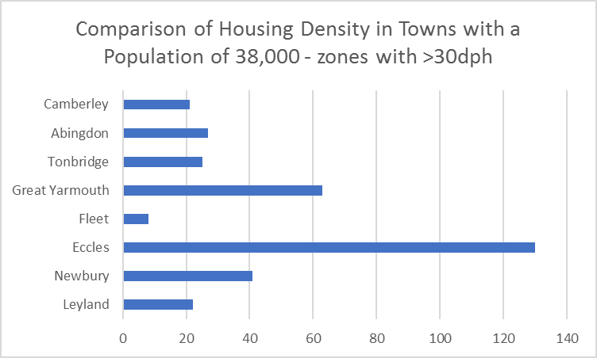
Fleet is the lowest density town of its size in the country. The chart below that there is significant scope for increasing development density in Fleet.

The retail offer in Fleet is poor, the cultural facilities (e.g. Harlington Centre) are outdated and there is no proper cinema.
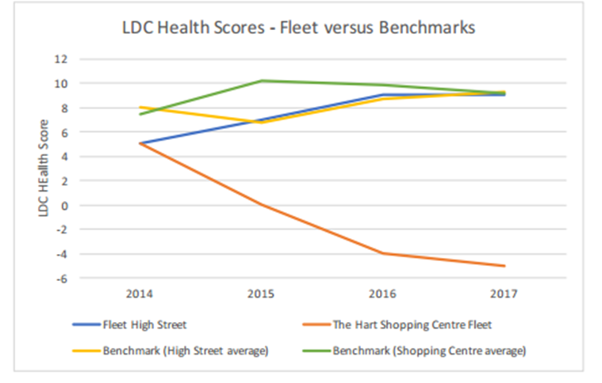
However, Fleet has the highest average earnings per person of comparative towns by quite a large margin (eg 9% more than Camberley). High earnings should give Fleet a significant advantage over the comparison towns.
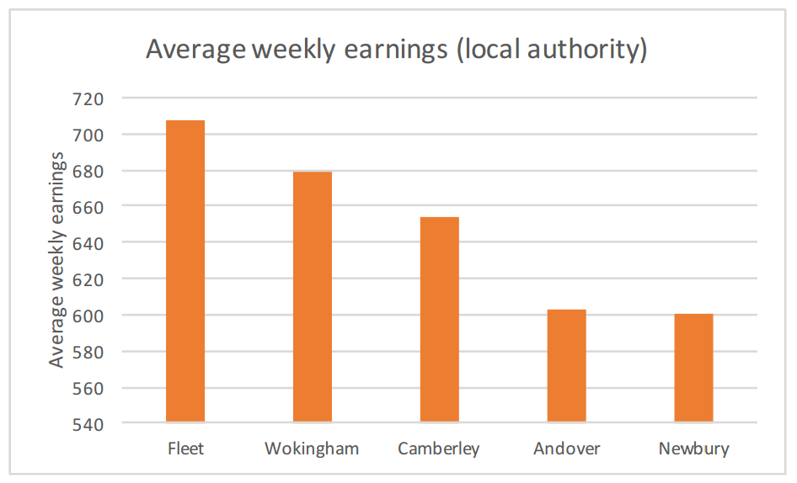
The Local Plan Vision and Objectives fail to take advantage of the opportunity to modernise Hart’s urban centres while at the same time protecting Hart’s countryside.
I believe that the Vision for the Local Plan should be centered on the proposition that Fleet and other urban centres will be re-generated. With Hart District Council’s full and active support, a plan based on urban regeneration would achieve the following benefits:
- An ambitious Hart Urban Re-generation Project (HURP) would attract private investment and thus be affordable
- HURP private investment would allow for Hart’s infrastructure to be upgraded in line with the urban re-generation
- HURP would use good urban design principles to achieve a higher population density in the urban centres while at the same time providing an improved ‘sense of place’ and making the urban centres more desirable places to live
A similar approach could be adopted in Yateley to provide a proper retail-led centre and improvements could be made to Blackwater. The requirement for additional retail facilities in Hook, identified in the Local Plan could also be met.
Apparently, Hart did have a plan to conduct a brownfield study to evaluate the ‘art of the possible’ in our urban centres. This project has not delivered.
In addition, Yateley lacks a defined centre, Blackwater is indistinct and Hook lacks good quality restaurants and shopping facilities.
You should be setting out a bold plan to improve the retail, cultural and recreational amenities in the district. The council should develop plans for a theatre and cinema in Fleet as part of an attractive mixed-use redevelopment. There will be significant cash available from developers to fund such an ambitious plan.
Moreover, you should work collaboratively with developers to improve our other urban areas such as Blackwater and redevelop the centres of Yateley and Hook.
Do you wish to comment on another part of the consultation? *
☒ Yes
☐ No
If Yes, please copy and paste and complete the comments section as before.

Comment 4
Please indicate the document and specific page, section or policy and paragraph you are commenting on:
☒ Draft Local Plan: Strategy and Sites
☐ Sustainability Appraisal
Page number/s:* 116
Section/Policy number:* Click here to enter text.
Paragraph: 395
Do you support, oppose or have general comments about this part of the document?*
☐ Support
☒ Oppose
☐ Comment
Please provide your comments below: *
Paragraphs 7, 17 and 177 of the NPPF/NPPG make clear that infrastructure should be planned alongside housing. Para 395 of the draft Local Plan says there’s a Draft IDP available for viewing alongside the Local Plan. However, no IDP has been made available.
Given that back in 2013, a £78m infrastructure funding deficit was identified, this is a critical omission. In particular, you should focus on:
- The requirement for a new secondary school. The Murrell Green proposal includes a site for a new school, albeit on top of a high-pressure gas main, but no evidence has been presented to demonstrate a new secondary school is actually required. WeHeart Hart research shows that a new secondary school may not be required, and the sustainability assessment for Murrell Green mentions a 9% surplus of places.
- SW Trains have indicated that the mainline rail route to London is 20% over-crowded at present and is forecast to be 60% overcrowded by 2043. Para 58 of the Local Plan makes no mention of this, and there is no apparent plan to improve capacity.
- Our roads are becoming increasingly congested and generally in a poor state of repair. There is no sign that the council has carried out an overall road transport assessment to establish the level of investment required to improve our roads so they can cope with the scale of development that is being proposed
- Paras 65 & 66 make no mention of groundwater and surface water flood risk in Winchfield, which was identified in the Sustainability Assessment
- Para 68 provides no plan to fix the acknowledged wastewater capacity issues
- None of the plans for the strategic sites include proper plans for sports and community facilities such as allotments.

Do you wish to comment on another part of the consultation? *
☒ Yes
☐ No
If Yes, please copy and paste and complete the comments section as before.

Comment 5
Please indicate the document and specific page, section or policy and paragraph you are commenting on:
☒ Draft Local Plan: Strategy and Sites
☐ Sustainability Appraisal
Page number/s:* 116
Section/Policy number:* Click here to enter text.
Paragraph: 395
Do you support, oppose or have general comments about this part of the document?*
☐ Support
☒ Oppose
☐ Comment
Please provide your comments below: *
I would like to challenge a significant omission in the Local Plan and Sustainability Assessment. Neither document contains a financial assessment of the alternative means of providing the housing need.
We already have a £78m infrastructure deficit, so this is a critical issue. The financial analysis should include:
- An assessment of the major infrastructure requirements generated by each of the approaches you have considered. These include new roads; road improvements such as roundabouts; railway station and parking improvement; railway line capacity improvements; schools; healthcare; fixed and mobile telecommunications, flood prevention, wastewater disposal and social infrastructure. A high level cost of each item should be provided.
- An assessment of the likely contribution that could be expected from developers and other providers to meet these requirements.
- An assessment of the likely contributions from Government such as New Homes bonus and grants to support brownfield development.
- An assessment of the gap between the requirement and the contributions for each development scenario
Residents should then be able to see the financial impact of the proposals.
Do you wish to comment on another part of the consultation? *
☒ Yes
☐ No
If Yes, please copy and paste and complete the comments section as before.

Comment 6
Please indicate the document and specific page, section or policy and paragraph you are commenting on:
☒ Draft Local Plan: Strategy and Sites
☐ Sustainability Appraisal
Page number/s:* Click here to enter text.
Section/Policy number:* Policies SS1, Sc2, MG6
Paragraph: 77
Do you support, oppose or have general comments about this part of the document?*
☐ Support
☒ Oppose
☐ Comment
Please provide your comments below: *
I would like to challenge the site allocations in Policies SS1, SC2, MG6, para 77 and the Policies Map.
Because Hart has over-stated the overall housing requirement (see response above), it has consequently allocated far too many sites for development. If the housing target outlined above is adopted, then none of the sites identified are required. Indeed, the brownfield sites can be kept aside for future development in subsequent plan periods.
If, however, the housing target identified above is not adopted, I would like to object to all the green field sites identified and in particular, Murrell Green (SC2).
This site is unsuitable for several reasons:
- It effectively coalesces Hartley Wintney and Hook, contrary to the vision (para 77) and policy MG6
- The proposal is obviously not thought through in that both the ‘Master Plan’ in the sustainability appraisal (STR11) and the schematic in the development framework show that the ‘Major Accident Hazard’ High Pressure Gas Pipeline has not been considered in the proposals. Indeed, the pipeline is not even mentioned as a constraint. Several issues arise:
  - The site of the new primary school building is directly on top of the pipeline
  - The pipeline runs through the grounds of the proposed secondary school
  - The retail/community area is adjacent to the pipeline
  - Housing is planned directly on top of the pipeline
  - New access roads cross on top of the pipeline 3 or 4 times, depending upon which version of the master plan is examined.
- The sustainability assessment says that the site is dependent upon several landowners and the planners have not directly confirmed the land is available.
- The promoter of the site ‘Lightwood Strategic’ has negative net assets (as per latest accounts to 31 January 2016) and is thus in no position to develop the site.
- Part of the site includes Beggars Corner which is the triangular piece of land between the railway and motorway. A proposal for a solar farm on this land was turned down at appeal last year. The main reasons for turning it down were:
- Harming the enjoyment of those walking the public footpath across the site. This is shown as a dotted red line on the map
- Spoiling the view from the Deer Park at Odiham
Houses are obviously taller than solar panels, and indeed some houses might have solar panels on their roofs. So, how can it be sensible to build houses when solar panels were deemed inappropriate?
Furthermore, a significant part of Beggars Corner used to be landfill, with unknown contents
- Part of the justification given for the new settlement is the alleged need for a new secondary school. However, no evidence has been presented that a new school is required. Indeed the sustainability appraisal states that there is a forecast surplus of 9% of secondary school places, and a response to an FOI request stated that a further 11% of secondary school pupils were from outside Hart district. Hampshire County Council needs to put forward a definitive statement on the number of secondary school places they think will be required in Hart up to 2032. This should cover a range of development scenarios, say 6,000, 8,000 and 10,000 new houses and state the ways in which they would prefer any excess demand be met.
Do you wish to comment on another part of the consultation? *
☒ Yes
☐ No
If Yes, please copy and paste and complete the comments section as before.

Comment 7
Please indicate the document and specific page, section or policy and paragraph you are commenting on:
☐ Draft Local Plan: Strategy and Sites
☒ Sustainability Appraisal
Page number/s:* 71, 74 .
Section/Policy number:* Click here to enter text.
Paragraph:
Do you support, oppose or have general comments about this part of the document?*
☐ Support
☒ Oppose
☐ Comment
Please provide your comments below: *
The sustainability assessment is weak on a number of issues:
First, the document fails to make clear that Winchfield West failed testing in STR005:
Nevertheless, we consider the whole of STR005 (WEST) is likely to perform significantly worse than STR005 (EAST) in viability terms, due to the extent and range of constraints impacting that part of the site, in addition to the lack of any unified site promotion or comprehensive approach to land assembly. This does not mean that there are no areas within STR005 (WEST) are likely to prove suitable or viable and some smaller pockets within this may come forward for development over time. However, in our view there is the risk that strategic-scale development across the western half of STR005 is unlikely to work sufficiently from a viability perspective due to the extent of the potential costs and delays involved in overcoming the various constraints.
Second, it fails to mention that 5 of the 8 SHLAA sites for Winchfield scored 55 or above on a 74 point scale. Even the Strategic Assessment (STR005 which was not published alongside the Local Plan, but had to be dragged out via FOI) downplays the flood risk. The area of Taplins Farm Lane flooded three times in 2016 alone, as documented here (4 Jan), here (7 Jan), here (9 March on Station Road) and here (28 March due to #StormKatie). Whereas STR005 says the area is only subject to surface water flood risk once every 30 years. This is clearly absurd.
Third, the capacity assessment must be seriously questioned. Back in November 2015, the capacity assessment in the SHLAA for sites SHL124 and SHL183 were 500-1,500 and 150 units respectively. This included 59Ha of SANG, but significantly no secondary school was planned in those sites. Now STR005 claims 3,243 units in total, plus a secondary school. The SA claims 3,000 units plus secondary school. What is the justification for increasing the capacity from 650-1,650 to around 3,000. Clearly, one of the documents is wrong, but we don’t know which one. The SANG requirement is at least 60Ha, plus additional space for sports facilities and community areas such as allotments. The indicative layout does not include a labelled SANG, not any sports pitches or allotments.
Fourth, the section on climate change mitigation proposes a locally sourced biomass plant for the Winchfield option. This is clearly nonsense. First, burning wood produces more CO2 per unit of electricity produced than burning coal. Second, where will the locally sourced timber come from? Bramshill forest is (or should be) protected, but where would the fuel for year 2 come from, the New Forest?
Fifth, there has been a shabby attempt by Gallagher and Curtin & Co to influence this consultation by their late publication of a ‘newsletter’ promoting a new settlement at Winchfield as being the only way to deliver a new secondary school. They have omitted to mention that the proposed location of the schools is directly under overhead power lines. Moreover, there’s an electricity pylon in the middle of the proposed sports pitches. Of course the school is also right next to the mainline railway. Overhead power lines have been linked to increased risk of childhood cancers such as leukaemia. It seems wholly inappropriate to be planning a new school (and there’s no evidence a new school is required) in such a dangerous location.
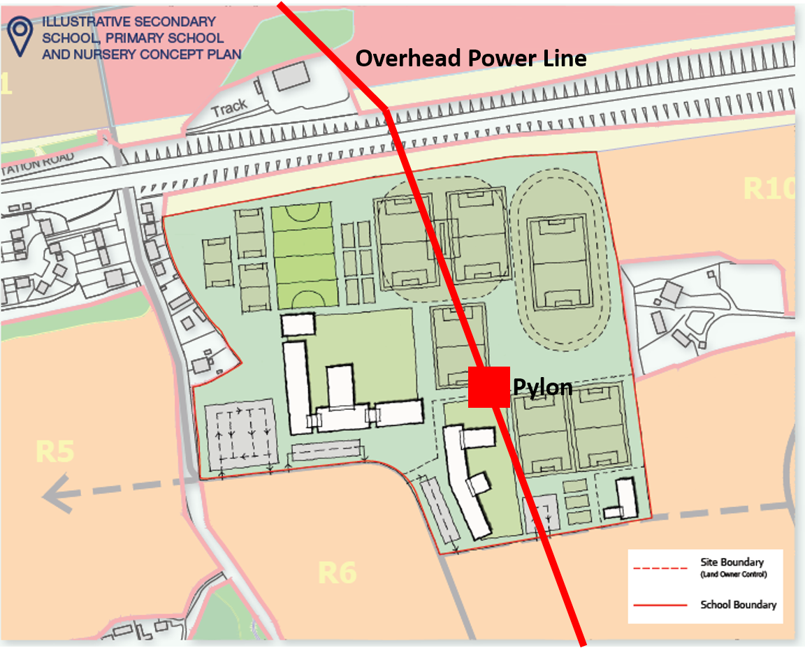
Finally, the master plan in the STR005 document does not include a power plant, so it is clear such a plant is not in the developer’s plans. Therefore, it is difficult to see how this can be used as a point of differentiation.

Equality monitoring questions – Please note that these fields are not mandatory.
The information that you provide below will help us identify which different demographic groups have engaged with this consultation.
How would you describe your ethnic group?
☐ White
☐ Mixed or Multiple Ethnic Groups
☐ Asian or Asian British
☐ Black or Black British
☐ Other – please specify Click here to enter text.
☐ I would rather not answer
If White please complete:
☐ White British
☐ White Irish
☐ White Traveller (including Gypsy, Roma or Irish traveller)
☐ Other White background
If Mixed or Multiple Ethnic Groups please complete:
☐ White and Asian
☐ White and Black African
☐ White and Black Caribbean
☐ Other Mixed background
If Asian or Asian British please complete:
☐ Nepalese
☐ Bangladeshi
☐ Indian
☐ Pakistani
☐ Chinese
☐ Other Asian background
If Black or Black British please complete:
☐ African
☐ Caribbean
☐ Other Black background
Do you consider yourself to have a disability as defined by the Disability Discrimination Act 1995 (2005)?
Definition: A person has a disability for the purposes of this Act if s/he has a physical or mental impairment, which has a substantial and long-term adverse effect on her/his ability to carry out day-to-day activities.
☐ Yes
☐ No
☐ Don’t know
☐ I would rather not answer
What is your gender?
☐ Male
☐ Female
☐ I would rather not answer
In which age category are you?
☐ Under 18
☐ 18 – 24
☐ 25 – 34
☐ 35 – 44
☐ 45 – 54
☐ 55 – 64
☐ 65 – 74
☐ 75 +
☐ I would rather not answer

Thank you for completing this form.
Please email this response to planningpolicy@hart.go.uk or send it to Planning Policy, Hart District Council, Harlington Way, Fleet, GU51 4AE.

