For office use only:
Respondent ID: Comment ID:

Respondent ID: Comment ID:

Draft Rushmoor Local Plan: Preferred Approach
June 2015

Consultation Comment Form

We are inviting you to take part in the consultation on the draft Rushmoor Local Plan Preferred Approach. This document sets out the vision for the borough and approach to development up until 2032.
The six week consultation period will run from Monday 8^{h} June to Monday 20th July 2015. Comments should be received by 5pm on the closing date.

When adopted, the Local Plan will play an important role in shaping Rushmoor’s future – how our towns will develop, protecting and enhancing our natural environment, developing our local economy, improving leisure and visitor facilities and supporting more sustainable forms of travel.

The draft Local Plan Preferred Approach contains a vision and objectives for the Borough up until 2032 and includes a series of policies under category heading. For most policies, the Council has identified its preferred approach and discounted options.

We would encourage you to comment online at www.rushmoor.gov.uk/newlocalplan
Before completing this comment form please note that:
- All valid comments (electronic or written) and the name(s) of the respondent will be made publically available. Personal contact details will remain confidential.

- Comments should only relate to the document titled above.

- Please complete all sections of this form fully and clearly. However, you do not need to respond to every question in the consultation paper.

- Please use a separate “Section 2” box for each comment that you intend to make.

- The Council can only consider comments made on the forms provided. Electronic copies can be downloaded www.rushmoor.gov.uk/newlocalplan

Before completing this comment form please note that:

- All valid comments (electronic or written) and the name(s) of the respondent will be made publically available. Personal contact details will remain confidential.

- Comments should only relate to the document titled above.

- Please complete all sections of this form fully and clearly. However, you do not need to respond to every question in the consultation paper.

The completed comments forms must be received by Rushmoor Borough Council no later than 5pm on 20 July 2015.

Please note that late representations may not be taken into consideration.

Please return this form to the Council via one of the following methods:

Post: Local Plan Preferred Approach Consultation
Planning Services
Rushmoor Borough Council
Council Offices
Farnborough Road
Farnborough
Hampshire
GU14 7JU
Or

Email: plan@rushmoor.gov.uk

For further information contact Planning Policy at Rushmoor Borough Council on 01252 398789

Section One: Respondent’s Details
All respondents should complete Part A. If you are an Agent, please complete Parts A & B
Part A: Respondent
Title / Name:
Job Title (if applicable):
Organisation / Company (if applicable):
Address:

Postcode:
Tel No:
E-mail:
Part B: Agents – Please complete details of the client / company you represent
Client / Company Name:
Job Title (if applicable):
Address:

Postcode:
Tel No:
E-mail:

I understand that my response(s) will be considered by the Council in preparing the Rushmoor Local Plan, and that my comments will be made publicly available and identifiable to my name and/or organisation. The information in this form is, to the best of my knowledge, correct.
Signed: David Turver | Dated: 2 July 2015

Section Two: Your Representation

Question 1: The vision and objectives
The draft Local Plan Preferred Approach vision should be both aspirational and achievable and set out the kind of Borough we will strive to become by 2032. To deliver the vision, eleven objectives are set out in the document. The vision and objectives for the Local Plan Preferred Approach have been developed from a range of strategies and through engagement with stakeholders.
- Do you think that the vision of the draft Local Plan Preferred Approach depicts / sets out the Borough that communities would want to be living and working in by 2032?
x

YES NO
Comments Box: In answer to the vision set out in section 4.3.
I would like to add to my submission made on 17 June.
Rushmoor is seeking to protect 96 Ha of employment land (according to the SHLAA), whereas the ELR shows that there will be a surplus of over 600K sqm (or around 195 Ha) of employment land even if the inflated jobs growth assumptions contained within it are achieved.
Therefore Rushmoor should revise its local plan and release more employment land for housing.
- Do you think that the strategic objectives of the draft Local Plan Preferred Approach identify the things that the borough needs to meet the vision for 2032?
x

YES NO
Question 2: The Local Plan Policies
Comments Box: In response to the Objectives set out in section 5.1
I would like to add to my comments submitted on 17 June
C. The Employment Land Review relies on the same Experian forecasts you describe as “Experian-derived forecasts which are considered unreliably high in that they make too many assumptions around unconstrained economic growth”.
Notwithstanding the above the ELR shows that even if the inflated jobs forecasts are achieved, there will be a surplus of ~600K sq m of employment space in 2032 (not to mention the surplus space in nearby districts), yet Rushmoor is seeking to protect 96 Ha of employment land.
This is clearly an untenable position and Rushmoor should release more land for housing so that it can meet its own (inflated) housing need within its own boundaries.
Please state using the comments boxes below which paragraph or policy of the draft Local Plan Preferred Approach you are commenting upon.
Please indicate which part of the document on which you are commenting, and use one box per comment (issue): (please create more comment boxes if you need to)
COMMENT BOX 1  Please identify the specific policy number or paragraph that your comment below relates to | Policy No:  Paragraph No: 6.25-6.28
Please indicate the nature of your comment: (mark ‘x’)
Support the Preferred Approach

Seek changes to the Preferred Approach
x
Support a Discounted Option

Suggest an alternative approach
x
General Comment

Please enter your comment below:
(Please be as concise as possible and include any changes that you would wish to see) (Continue on a separate sheet if necessary)

The Employment Land Review (ELR) shows there is a massive surplus of around 600K sq m employment space occupying around 195 Ha of land across the combined area of Hart District, Surrey Heath and Rushmoor Boroughs. Despite this, Rushmoor is seeking to protect 96 Ha of land for employment. More detail on this is given in Appendix D.

The Local Plan should be revised and more employment land should be freed up for housing to help Rushmoor meet its assessed need within its own boundaries.

PLEASE ENSURE YOU HAVE READ AND SIGNED THE DECLARATION ON THE RESPONDENT DETAILS SECTION ON PAGE 3
Thank you for taking the time to give us your views

Appendix D: Too much protection being afforded to employment land

The Employment Land Review (ELR) shows there is a massive surplus of around 600K sq m employment space occupying around 195 Ha of land across the combined area of Hart District, Surrey Heath and Rushmoor Boroughs. Yet, Rushmoor is seeking to protect acres of this land whilst at the same time trying to force Hart to build 1,600 houses for them on beautiful green fields.
 | Employment Space (sq m)
Overall Requirement to 2032 (a) | 266,368
Current vacant space (b) | 527,840
Sites with planning permission (c) | 338,187
Surplus in 2032 (b+c-a) | 599,659

The analysis to support the conclusion is shown below. The ELR is based on the same flawed jobs forecasts as the housing market assessment that predict a near doubling of the job creation rate we achieved in the period 1998-2012. However, even if you accept these flawed forecasts, the requirement for employment land in the combined economic area is 266K sq m using Rushmoor’s preferred Scenario 3.
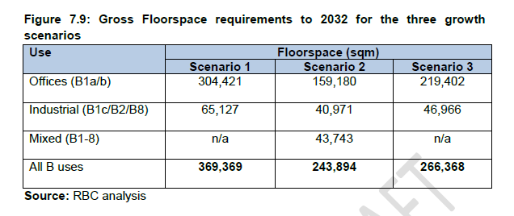
Figure 1: Figure 7.9 reproduced from the ELR
However, as of December 2014, over 527K sq m of employment floorspace was lying vacant:
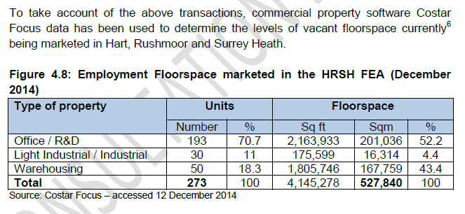
Figure 2: Figure 4.8 reproduced from the ELR
Moreover, there is a glut of employment space all across neighbouring districts with very high levels of vacant office space (note that there are also high vacancy rates on industrial land):
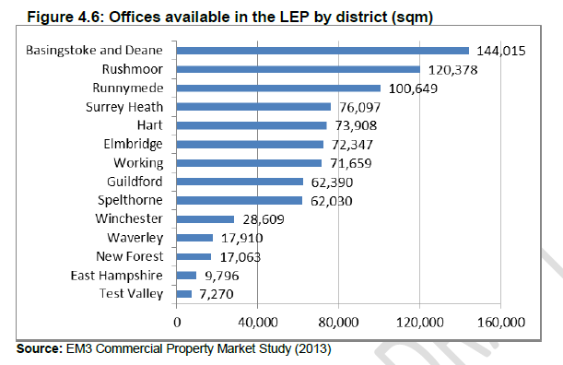
Figure 3: Figure 4.6 reproduced from the ELR
In addition to the vacant units shown above, there is currently 388K sq m of floorspace on 110 Ha of land that currently has planning permission but is not yet being built:
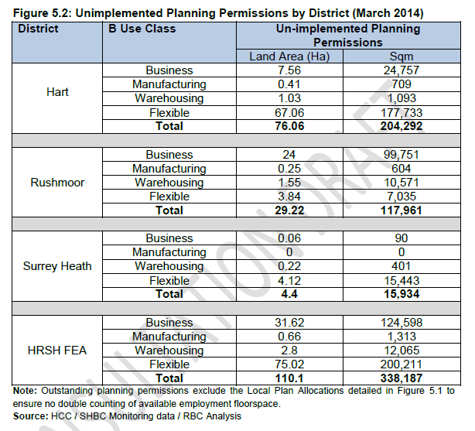
Figure 4: Figure 5.2 reproduced from the ELR
Drawing this together, there is a need for 266,000 sq m of space to meet the inflated employment forecasts, there’s currently 527,000 sq m lying vacant, with a further 338,000 sq m with planning permission, but not yet built. This would leave a surplus of nearly 600,000 sq m of employment space that might occupy around 195 Ha of land, using the same ratio of employment space to land use as the existing planning permissions.
Despite the above, Rushmoor is seeking to protect 96 Ha of employment land despite the large forecast glut of space.
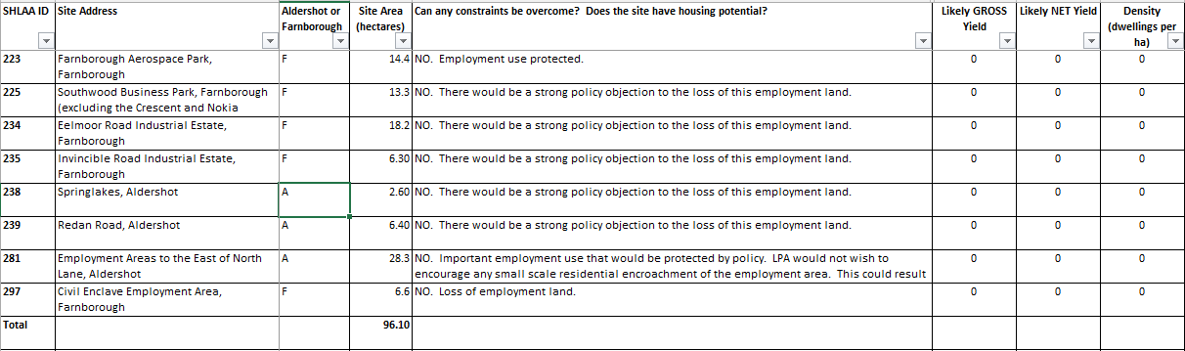
Figure 5: Rushmoor Protected sites from SHLAA
It is clearly ridiculous for all of this land to be protected if even half of this was used for housing at 100 dwelling per hectare, it would yield 4,800 houses for people in Rushmoor and would mean that Rushmoor could meet its own housing need and even take some of Hart and Surrey Heath's allocation.
Sources:
http://wehearthart.co.uk/2015/05/rushmoors-employment-land-review-has-errors-that-reduce-brownfield-site-availability/
http://wehearthart.co.uk/2015/07/massive-surplus-of-brownfield-employment-land-but-rushmoor-wants-hart-to-concrete-over-green-fields/
http://wehearthart.co.uk/2015/06/rushmoor-protecting-acres-of-vacant-offices-and-asking-hart-to-build-1600-houses-for-them/

http://wehearthart.co.uk/2015/05/rushmoors-employment-land-review-has-errors-that-reduce-brownfield-site-availability/

