Questions for Hart Council Regarding Local Plan

I would like to ask the following questions at the council meeting on 26 March 2015

Planned Housing Density on Brownfield and other sites
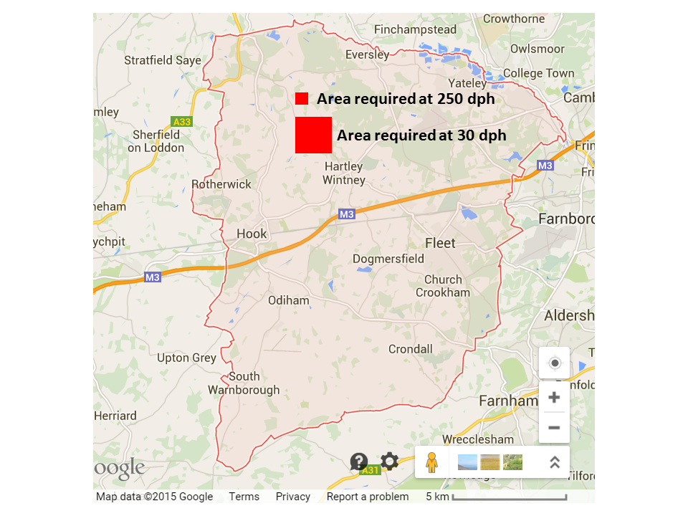

The analysis of the results of the FOI request about brownfield sites showed that the council doesn’t have a very robust approach to identifying and analysing brownfield sites in the district. However, further analysis also shows that the council adopts a rule of thumb for housing density of around 30 dwellings per hectare (dph). However, a study by a local architecture student has shown that in urban areas a planning density of around 250dph can create vibrant communities. This kind of metric could be applied to brownfield sites in both Hart and neighbouring districts such as Surrey Heath and Rushmoor. For instance, the Aldershot Barracks site could take all of Rushmoor’s entire requirement and maybe some of Hart’s too. Moreover, Hart District’s overall housing requirement of 7,534 dwellings would require ~251 hectares of land at 30dph, but only 30 hectares of land at 250dph. Building at a higher density would mean that a site such as Hartland Park could theoretically take Hart’s entire allocation.

Question: What is Hart District Council’s strategy for applying pressure to for instance Rushmoor to build at a higher density on the Aldershot Barracks site?
Answer: I do not necessarily accept the points made in the preamble, but I will answer the substantive questions. Aldershot Urban Extension was granted planning permission in 2013 for 3850 dwellings. It is not lawfully available to Rushmoor Borough Council to withdraw that consent, and thus time and resources spent in that regard would be a waste of public money. If the developer were to seek a fresh consent at a higher density consistent with good planning, we will look at it on its merits but I suspect we would support it.
However, we have objected to Rushmoor’s Masterplan for the Farnborough Civic Quarter on the basis that they should explore greater housing densities. We have made sure that their SHLAA will be subject to an independent validation exercise to ensure it has been prepared in line with national planning guidance.
We will look at the SHLAA ourselves to see if there is scope for them to increase their densities or bring more sites in.

Question: What steps are Hart DC taking to investigate building at higher density on brownfield sites to protect our valuable green fields avoid urban sprawl?
Answer: Hart is examining all sites with a view to maximising densities, again where consistent with good planning. However, Mr. Turver’s contributor is proposing a very high density. Viability guidance considers densities of 80dph for urban mixed development; even for urban flatted development it is only proposing 160dph. We might approach these levels for town centre sites, but beyond that it would amount to the construction of purpose designed slums.
However, to boost the supply of housing on brownfield sites Hart has written to local agents that are advertising office space in Hart to invite their owners to consider residential use. This includes sites at Ancells Farm, the offices on Fleet Rd and Bartley Wood, Hook.
We are also talking to the owners of Hartland Park to see whether that can be made available for housing.

Planning for the Ageing Population
Hart District Council it has a duty to meet the needs of many groups in society. Para 50 of the NPPF states:
“local planning authorities should…plan for a mix of housing based on current and future demographic trends, market trends and the needs of different groups in the community (such as, but not limited to, families with children, older people, people with disabilities, service families and people wishing to build their own homes)”
Over the course of the plan period up to 2032, there will be an extra 10,000 people over 60, including more than 6,850 over 75, expected to be living in the district and an extra 3,620 people who will be suffering from dementia or have some sort of mobility problem.
This will lead to a demand for additional specialist accommodation for older people. Let’s assume on average there’s 1.5 older people per dwelling because so many live on their own. That would be 6,850/1.5 = 4,566 units. Not all of them will want to leave their existing homes and some may go and live with family. So, let’s say we need half that number of new dwellings. That’s in round numbers 2,280 units. This assumes that all of the extra people with a mobility problem are also aged over 75.
Now let’s look at supply. Of the 7,500 houses we need to build up to 2032, around 3,500 have already been given planning permission, which leaves a balance of around 4,000. Of the 3,500 some are specialist units for the elderly – I know of a Churchill and McCarthy and Stone development in Fleet which will total around 100 units. This leaves around 2,180 units to find for the elderly.
If we were to build a new town and deliver around 2,000 units (this is much lower than the Barratts vision document) in the plan period, then this would leave around 2,000 units still left to grant planning permission for elsewhere.
As can be seen, if we build the new town, we will not meet the needs of the ageing population unless all of the remaining units are specialist units for the elderly and thus run the risk of the local plan being found unsound.
Question: What are the council’s plans to meet the needs of the ageing population in the local plan?
Answer: The preamble to this question based it on a chain of speculative assumptions. The Strategic Housing Market Assessment specifically addressed the issue of specialist housing and constitutes an evidence based assessment, on which we can rely and which discussed the matter of projected accommodation needs for the elderly in considerable detail. We will also be seeking discussions with Hampshire County Council Social Services to help them deliver their aspirations for the elderly, for example more Extra Care accommodation.
Hart would seek to provide for specialist housing in any substantial settlement, particularly where the services the occupants might require are provided as part of the infrastructure.
But I would also expect accommodation for the elderly in its various forms to be provided at other settlements too. Examples include higher density schemes like the Churchill one on Fleet Rd/Branksomewood Rd, and the care village such as that being completed in Yateley.

Infrastructure Costs

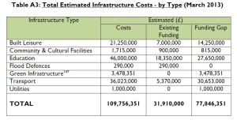
According to council documents, there is a current funding gap of around £78m for infrastructure in the district, not including the infrastructure requirements of a new town nor additional healthcare provision. Surrounding districts are also under pressure to build thousands of new houses in the plan period which will generate additional journeys within Hart because of identified work patterns.
Question: What additional CIL or S106 funding might the council expect to receive for building the additional 4,000 or so houses not already given planning permission?
Answer: Experience shows that willing party negotiations achieve significantly better results than those resulting from contested planning applications granted at appeal. That said, Hart has yet to finalise its CIL regime.
Question: How will the amount of money vary according to the development strategy adopted (e.g. New Town versus Strategic Extensions versus Dispersal)?
Answer: CIL is likely to vary with the part of the district where it is located, and this is a function of the financial viability of building in those areas. S106 depends substantially on the specific needs of the location in question. For example, Dilly Lane, now called St Mary Park, in Hartley Wintney, required works to facilitate access to the A30 funded by S106 whereas another development may not have such a requirement. Whichever strategy is selected there will be a combination of CIL receipts, and on-site infrastructure secured through S106. The balance between these two will vary – a new settlement strategy would generate greater S106 on-site provision of infrastructure and less CIL revenue. A dispersal strategy would generate more CIL revenue than on-site provision.
Question: How will the infrastructure requirement and costs vary according to the development strategy adopted?
Answer: The requirement and costs will vary according to the site rather than the strategy.
Discussions are currently taking place with key infrastructure providers and relevant agencies (e.g. Hampshire County Council, Thames Water, Environment Agency, Highways Agency, Network Rail) to establish the infrastructure issues that need to be addressed for all the different strategic sites, including Winchfield.
Question: What analysis is Hart carrying out to evaluate the impact on Hart’s infrastructure of rising population in neighbouring districts?
Answer: All the principal infrastructure providers are either statutory consultees or discretionary ones who we will ensure are consulted. They are aware of pressures on them from other districts and will take those pressures into account when responding to Hart. Further, neighbouring authorities are governed by the Duty to Cooperate, and we will make appropriate arrangements with them.
Question: How will Hart DC factor into its analysis the varying funding requirement and availability of alternative development strategies?
Answer: The process of testing the major sites including but not limited to those in the current preferred strategy includes an assessment of the infrastructure requirements of all of those sites set against the viability tests performed in accordance with guidance.

The Council is currently trying to establish the infrastructure requirements associated with different strategic sites, whether or not they are viable once affordable housing requirements are factored in, and whether supporting infrastructure would be best secured via S106 or through CIL. This is Part 2 of the Cabinet paper 8th January 2015.
This will be part of the information that will inform decisions on which sites should be allocated in the plan.

http://wehearthart.co.uk/2015/02/hart-district-council-has-no-brownfield-strategy/
http://wehearthart.co.uk/2015/03/rushmoor-could-take-all-of-harts-allocation-and-more/
http://wehearthart.co.uk/wp-content/uploads/2015/02/Hart-DC-Infrastructure-Delivery-Schedule-October-2014-Part-A-v2.pdf

